Contemporary Canadian Politics

| Partisan Gaze: Examining the Impact of Political Party Preferences on Exposure to News Content (An Eye-Tracking Study)
Mary Toma
Keywords: Selective exposure, selective avoidance, eye-tracking, partisanship, disconfirmation bias, horizontal attention bias
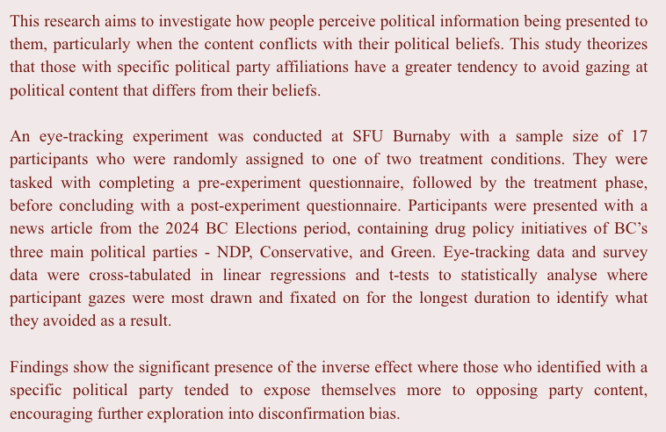

Introduction
In a politically polarized world, people are not passive recipients of information but rather selectively choose, whether consciously or unconsciously, what it is that they would like to be exposed to. This is known as selective exposure theory (also referred to as confirmation bias), a concept first introduced by Lazarsfeld et al. (1948 as cited in Knobloch-Westerwick, 2015, p. 5). Selective exposure occurs when individuals hold attitude-driven biases and will only interact with political information that reaffirms their beliefs (Garrett, 2009, p. 678; Schmuck et al., 2019, p. 158; Sülflow et al., 2019, p. 169). In having access to such a vast amount of information yet only choosing to encounter reaffirming content, this leaves us wondering whether people are actively avoiding looking at opposing information.
Selective avoidance occurs when there is “a tendency to avoid opinion challenging information systematically” (Jang, 2014, p. 668), and is a separate phenomenon that arises regardless of whether reaffirming information is present or not (Schmuck et al., 2019, p. 160). My research aims to refine selective exposure theory to account for how people with established political identities may avoid viewing content that contradicts their beliefs, contributing to broader discourse on selective avoidance theory.
I conducted an eye-tracking experiment where participants were presented with political news content on drug policy. The use of eye-tracking technology to measure the visual attention of participants provided empirical evidence for examination while deepening understanding of public perceptions towards political news content and the role that biases may play in our subconscious interactions. Visual attention in this case, refers to “what the eyes are looking at” (Segijn & Vraga, 2024, p. 115), and was assessed to determine where participant gazes were most drawn and fixated to deduce what they avoided as a result.
The reason for selecting drug policy as the content shown to participants is due to Canada declaring the opioid crisis a national emergency back in 2016, with British Columbia (BC) alone having the highest rate of illicit drug use and overdose deaths (Belzak & Halverson, 2018, p. 226). In 2024, BC Emergency Health Services (BCEHS) reportedly responded to 40,543 calls for overdoses and poisonings, averaging to about 111 calls per day (BCEHS, 2025). As citizens of a democratic institution, it is our responsibility to seek the implementation of adequate drug policies that work to resolve such a widespread issue.
Ensuring that individuals are knowledgeable about the proposed drug policy initiatives from the respective political parties is a step in the right direction. However, factors such as partisanship which is “an individual’s adherence to a particular party or platform” (Klar, 2014, p. 687), present a challenge to the way people choose to perceive political information. This is where cross-cutting exposure theory comes into play.
Mutz (2002) defines cross-cutting theory as exposure to “dissimilar political views” (p. 111). It is largely believed that exposing individuals to diverse content including both reaffirming and opposing information, increases political tolerance (Matthes & Marquart, 2015, pp. 134-135; Peterson & Kagalwala, 2021, p. 585; Sülflow et al., 2019, p. 169). My study employs this theory by visually exposing participants to political information from BC’s three main political parties to evaluate how they view the material being shown.
At a societal level, understanding whether partisanship impacts visual attention (by causing people to deliberately avoid certain information) will provide valuable insight to both politicians and news reporters seeking to keep the public politically informed. Ultimately, this research seeks to answer: To what extent do people's political beliefs affect the visual attention of participants when presented with reaffirming and opposing information on drug policy initiatives? It is important to note that this study will not go in depth about the specific policies that should be established to mitigate the crisis, but rather the way in which people visually expose themselves to political information on such drastic issues.
Before discussing the findings of my study, I begin by reviewing existing literature on partisanship and various exposure theories. I am particularly interested in uncovering a phenomenon known as selective avoidance and seek to identify the extent to which it exists based on the strength of people’s partisanship by performing eye-tracking analysis. Then, I describe the details concerning the collection of my primary data. Before interpreting the results by combining pre-experiment survey data with eye-tracking data. Finally, I conclude by explaining what my findings mean and offer suggestions for future research to potentially investigate.

Partisanship
There is extensive literature exploring how an individual’s political beliefs shape their attitudes, ultimately influencing their levels of political participation. Greene (2002) writes that “partisanship clearly fits the psychological definition of an attitude” (p. 172) and goes on to state that it is representative of “the social-psychological concept of group identification” (p. 172). Building on this conceptualization, this paper examines how partisanship as an independent variable leads to selective avoidance, since individuals are believed to seek information that reinforces their political identity while avoiding content that challenges it (Sude & Knobloch-Westerwick, 2022, p. 88). Lelkes and Westwood (2017) find that as partisanship levels increase, avoidance of individuals with opposing viewpoints also increases (p. 486). While this confirms the existence of selective avoidance as a phenomenon among partisans, Lelkes and Westwood’s (2017) research reveals that it occurs based on physical interactions whereas I am assessing visual selective avoidance to political information.
The major ongoing debate amongst researchers concerns partisanship and selective exposure. By analysing existing literature, we can determine that much of the research wants to understand why strong political beliefs have such a prominent impact on political participation. Stroud (2007) mentions that partisan selective exposure may even be a false belief because individuals often seek to expose themselves to unfamiliar views to be more informed (p. 343). However, she goes on to write that if partisan selective exposure did not exist, then people would not be motivated to be active political participants (p. 343). An example showcasing how partisanship impacts selective exposure is offered by Areal (2024) who writes about the rise in negative partisanship where individuals do not identify strongly with a preferred party but are instead “motivated by their dislike towards a particular party or ideological group” (p. 1). It is evident that when there is a higher avoidance of content that discusses any differing viewpoints, the greater the negative attitude towards opposing political parties and their policies (Peterson and Kagalwala, 2021, p. 586). When combined with selective exposure, this idea of negative partisanship raises concerns about how people seek information, often reflecting a concept known as disconfirmation bias defined later in this research.

Horizontal Attention Bias
An important consideration on the topic of selective exposure as it relates to this study, exists in the fact that native English speakers are programmed to read content from left to right. Dickinson and Intraub (2009) identified an asymmetry in visual attention, reporting that individuals are more likely to initially direct their gaze towards the left side of the screen rather than the right (p. 1257). Churches et al. (2017) aimed to discover whether such asymmetries exist across horizontal and vertical spatial dimensions through experimentation. Their study finds evidence of an imbalance of horizontal visual attention directed towards the left of a stimuli due to space-based mechanisms (p. 457). Space-based mechanisms describe how attention is directed towards locations in a visual field, which differ from object-based mechanisms that describe attention towards objects (Churches et al., 2017, pp. 456-457). Based on this research and an understanding of potential bias arising in my own research, the first hypothesis reads as follows:
H1: Irrespective of partisanship, individuals are expected to allocate greater visual attention to content presented on the left of the screen when compared to the right.

Selective Exposure and Selective Avoidance
The prevailing view is one that has been identified as selective exposure theory. Hart et al. (2009) state that “Selective exposure enables people to defend their attitudes, beliefs and behaviours by avoiding information likely to challenge them and seeking information likely to support them” (p. 2). Peterson and Kagalwala find that selective exposure to content in online environments, leads individuals to hold negative views of those with opposing beliefs - mainly in relation to news media (2021, p. 586). In comparison with selective exposure occurring as an individual’s information-seeking process, Ohme (2021) finds that the use of algorithms in social media settings simulates an accelerated ability to encounter information that reinforces one’s beliefs (p. 37). This is further supported by Schmuck et al. when it is stated that, “In the age of ad blockers, filter algorithms, and TV streaming services, it has never been easier to avoid political advertising with relatively low effort” (2019, p. 158). While my study does not look at the effect of algorithms and how they may play a role in exposure to political news content, it is beneficial to consider these findings and how they reinforce the idea of selective exposure in a political context. The more people are exposed to selective content that fortifies one’s existing beliefs, the greater the divide grows between individuals within society.
While selective exposure involves actively seeking out information that aligns with one’s existing beliefs, it can also pave the way for selective avoidance, where individuals deliberately steer clear of information that challenges their perspectives. Assessing selective avoidance among partisans has been explored by previous studies and has yielded mixed results. Garrett (2009) finds high evidence of partisans seeking to reaffirm themselves through self-reports of selective exposure, however this did not entail an avoidance of opposing information (pp. 693-695). Likewise, Jang (2014) who relies on self-reported data after presenting participants with reaffirming, neutral, and opposing information, concludes that there is “compelling evidence for selective seeking but little evidence for selective avoidance” (p. 679). Opposingly, Bode et al. (2017) employ the use of eye-tracking technology alongside survey data to find evidence of selective avoidance and determine that when political cues are present on a social media post, people will spend less time looking at the post (p. 2). This suggests that selective avoidance is apparent, however Bode et al. did not account for partisanship which they recommend future researchers to consider (p. 5). Schmuck et al. also use eye-tracking and survey data to measure whether participants avoid looking at certain political poster ads and find “initial evidence for selective avoidance of political ads that are inconsistent with one’s partisan ideology” (2019, p. 161). This means that testing for the presence of selective avoidance is more precise and accurate when eye-tracking technology is incorporated conjunctively with survey data.
To test for the occurrence of selective avoidance, I chose to replicate the design used by Schmuck et al. (2019) while substituting for elements that were relevant to my research. For instance, their method consists of showing participants 12 political poster ads from Austrian parties, where Liberal and Conservative party ads were shown situated next to neutral party ads (p. 160). The researchers chose to have the ads appear on screen for 6 seconds and tracked the eye-movement of participants before making them complete a post-experiment survey (p. 160). I share similar techniques which are described in detail under the method section.
The second hypothesis was established to detect the presence of selective avoidance among partisans when presented with political content using cross-cutting methods. Thus, the second hypothesis reads as follows:
H2: If an individual self-identifies with a particular partisanship, then they will avoid gazing at opposing political content.
Along this reasoning a sub-hypothesis was also developed to account for those who had weaker political party affiliations and reads:
H2a: If an individual self-identifies as having weaker ties with their chosen political party, then they will show a balanced gaze towards reaffirming and opposing content.

Cross-Cutting Exposure
Another prominent theory in the literature is known as cross-cutting exposure theory. Matthes et al. (2019) explain cross-cutting exposure to be “the disagreement in viewpoints encountered by individuals in their communication environments” (p. 523). Basically, this entails being exposed to a variety of political beliefs that may differ from one’s own. Mutz (2002) assumes that cross-cutting theory has negative consequences for political participation amongst those exposed to beliefs different from their own and offers two alternate theories for why this is true (pp. 840-841). The first being an ambivalence explanation which occurs when differing views result in increased tolerance, hindering political engagement out of hesitation from one’s own beliefs (Mutz, 2002, p. 840). The second, a social accountability explanation arises when people would rather sacrifice their political participation than to act in a way that impacts their social relationships with others (Mutz, 2002, pp. 840-841). Ultimately, there are claims that cross-cutting exposure causes partisans to engage in more hesitant political behaviour, however other research finds that it fosters tolerance to opposing viewpoints and creates effective deliberation in political settings (Garrett, 2009, p. 694; Matthes & Marquart, 2015, p. 135; Peterson & Kagalwala, p. 588).
Matthes and Marquart (2015) write that being exposed to political beliefs that differ from one’s own, are essential to the existence of a sound society because it helps to create “political tolerance, increase the awareness of oppositional opinions, and encourage political engagement” (p. 135). Sülflow et al. (2019) agree that being exposed to cross-cutting viewpoints is beneficial because it leads to “effective deliberation and significantly influences the ability to seek political solutions in the case of disagreement” (p. 169). This study uses cross-cutting practices to expose participants to reaffirming opposing information, aiming not only to test for selective avoidance but also to assess for balanced engagement towards opposing viewpoints.

Disconfirmation Bias
Disconfirmation bias occurs when individuals who hold preconceived beliefs are exposed to communication on a topic and tend to “assimilate congruent evidence uncritically but vigorously counterargue incongruent evidence” (Taber & Lodge, 2006, p. 756). This line of reasoning is consistent with the social-psychological work of Ditto et al. (1998) who write that “preference-inconsistent information is seen as less valid than preference-consistent information because individuals faced with information they prefer not to believe recruit memories with the goal of undermining the validity of that information” (p. 54). Therefore, it is important to consider that a potential reason for higher exposure to opposing information corresponds to cognitive processes where the individual argues against the information they are perceiving. The presence of disconfirmation bias is further discussed in the results section of this research.

Method
The overall design of my study was a laboratory experiment where participants were tasked with looking at information on BC drug policy initiatives on a computer screen while having their eyes tracked. My study took inspiration from Schmuck et al. who recruited 76 total subjects in their study (2019, p. 160), however I recruited only 17 participants making it a smaller sample size. Individuals were recruited at Simon Fraser University (SFU) Burnaby using various approaches such as distributing flyers, a departmental email sent to all political science students, and through word of mouth across different areas of campus. These strategies were pursued to create a more diverse pool of participants while limiting potential bias. Participants were incentivized to join the study through the offer of a $30 Amazon gift card. Participation in the experiment was entirely voluntary, and participants were allowed to withdraw at any point in the study so long as it occurred prior to the submission of this paper, with the information collected remaining completely confidential and being destroyed wholly afterwards.
Participants were first presented with a pre-experiment questionnaire on SurveyMonkey that collected information relating to demographics such as: gender, age, city, and education. Participants were also asked questions relating to politics such as: their level of partisanship, electoral participation, ranking political issues, and how they stayed informed about political news. Non-responses were also recorded since the questionnaires generated the selection of ‘Don’t know’ answers. (Refer to Appendix 1 to view a sample of the pre-experiment survey). The post-experiment questionnaire contained more open-ended questions and was used to gather the thoughts of participants after reading the different party positions on drug policy initiatives. These results and their implications are discussed in greater detail in the conclusion.
In terms of the type of information presented to participants, they were shown a document containing NDP, Conservative and Green political party content. The implementation of the BC Green party was meant to introduce a neutral party stance amid more left-leaning (NDP) and right-leaning (Conservative) content. My study uses political content from news articles which is an essential feature of my research compared to the political poster ads used by Schmuck et al. (2019, p. 160). I chose to use online news articles as a mode of delivering information because it is one of the main sources of information that is widely available and accessible by the general population (Xenos et al., 2018, p. 719). Overall, the replication of a previous study boosted external validity and the generalizability of the research since I aimed to confirm previous findings under different conditions.
In my study, I used a CBC news article that described the various party positions from the 2024 BC Elections. I extracted snippets from the section titled “Mental health and addiction” (Dickson et al., 2024), where each party went over their proposed plan to mitigate the ongoing opioid crisis. The snippets were pasted onto a document where the article title appeared at the top of the page followed by the title of the section where each party position is listed. Below that, the platforms of BC’s NDP, Green, and Conservative party were pasted and the order in which they appeared differed across two different documents depending on which treatment condition participants were assigned to. The Green party position remained fixed in the centre, to maintain neutrality, whereas the NDP and Conservative platforms were swapped. The treatment group had the NDP appear on the left, with Conservatives appearing on the right. The control group had Conservatives on the left, with NDP on the right. These documents were randomly assigned to participants as a control measure to account for the fact that participants might have been inclined to read whichever party platform appeared first. (Refer to Appendix 2 to view a sample of these documents).
To test for the hypotheses, eye-tracking was used to measure visual attention because it allowed for a closer inspection of what people focused on in milliseconds when they physically gazed at something. This was done by assessing elements of visual attention such as area of interest (AOI) and the duration of fixations within those areas (Segijn & Vraga, 2024, p.113). In the Tobii software, three areas of interest were established on the two treatment documents where each party’s position appeared, and fixations were mapped by following the gazes of participants from their recorded sessions. The independent variable was established as being the political party affiliation (partisanship) of participants. The strength of partisanship was of particular interest when testing for the sub-hypothesis. There were two dependent variables examined, the first consisted of the time (milliseconds) spent gazing at NDP content, and the second being the time (milliseconds) spent gazing at Conservative content. The data from the eye-tracking recordings was then used in conjunction with data from the pre-experiment survey for cross-tabulation. All data was coded using JASP software and used to perform statistical analyses.
The combination of eye-tracking data with pre- and post-experiment survey data aided in the credibility and validity of my findings by allowing me to build a more comprehensive understanding of the phenomenon under investigation. I also performed linear regressions, like Schmuck et al. (2019) to analyse the data collected from the eye-tracking experiment and cross-referenced this with the survey data to identify whether partisanship had a causal effect in the selective avoidance of opposing content.
A limitation present when conducting an eye-tracking study is how time-consuming it is. From setup to the interpretation of the results, the use of this device proved to be more time intensive than initially thought. Another limitation of following this research design involved the recruitment of such a small sample size. This was anticipated as leading to difficulties in finding evidence of a causal relationship between partisanship and selective avoidance of opposing political information. This was mitigated through the experimental approach of data collection by manipulating the treatment so that conclusions can be drawn more precisely. Also, a potential source of bias in my data source arises due to the lack of variation in the participants’ political beliefs since they share similar demographics. I aimed to resolve this issue by recruiting individuals from different areas of campus to develop a diverse pool of subjects. Frequency tables indicating the program of study of participants showed a diverse array of results with two students in business, three from criminology, and a majority of five from political science – mainly due to recruitment efforts occurring through a departmental email for those students (see Appendix 3 for more info). Ethical issues when performing an experimental design were also taken into consideration and ethics approval was obtained.
Ultimately, this study worked towards determining whether people truly avoided looking at opposing political information, especially as it related to urgent societal matters. If selective avoidance appeared to be of major issue, this would hold greater implications when establishing public policies, delivering political content, and fostering political engagement.

Results
Two main hypotheses and one sub-hypothesis were generated to determine the extent to which people viewed political content on drug policies. The first hypothesis states that:
H1: Irrespective of partisanship, individuals are expected to allocate greater visual attention to content presented on the left of the screen when compared to the right.
This hypothesis was important for reducing potential bias in the results, as English speakers naturally read from left to right. By including two different treatment conditions, the study was able to test whether this tendency existed and ensured that any observed effects were due to the experimental conditions themselves - not just the layout of the content, which boosted internal validity.
For the first hypothesis, a t-test was conducted to determine how long participants gazed at NDP content when it appeared on the left or the right of the document, and the same was done for Conservative content. Figure 1.1 below shows that the average duration spent gazing at NDP content in the control group when it appeared on the right, was 23,602 milliseconds. Whereas the average duration spent gazing at NDP content in the treatment group when it appeared on the left, was 30,743 milliseconds. (See Appendix 4 for more info). This means that when NDP content appeared on the left side of the screen, participants gazed at it for approximately 7,141 milliseconds more than if it appeared on the right. The p-value must be less than 0.10 to be statistically significant for such a small sample size. Since the p-value is 0.14 for this test, this means that it is not statistically significant.
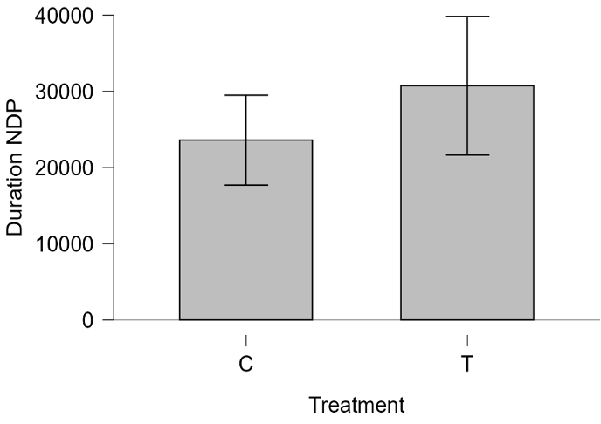

Figure 1.1: Average duration (milliseconds) spent gazing at NDP content
The next test for the first hypothesis was done to assess the duration of time spent observing Conservative content in both the treatment and control groups. Figure 1.2 below shows that 23,101 milliseconds were spent viewing Conservative content in the control group when it appeared on the left. Whereas an average duration of 25,531 milliseconds was spent on Conservative content in the treatment group when it appeared on the right. (See Appendix 5 for more info). Therefore, participants spent approximately 2,430 milliseconds more looking at Conservative content on the right side of the document meaning we can reject the first hypothesis. The p-value for this test is 0.61 which exceeds the threshold for statistical significance. In sum, I found no evidence to suggest that individuals have a tendency to gaze at content on the left of the screen to a greater extent.

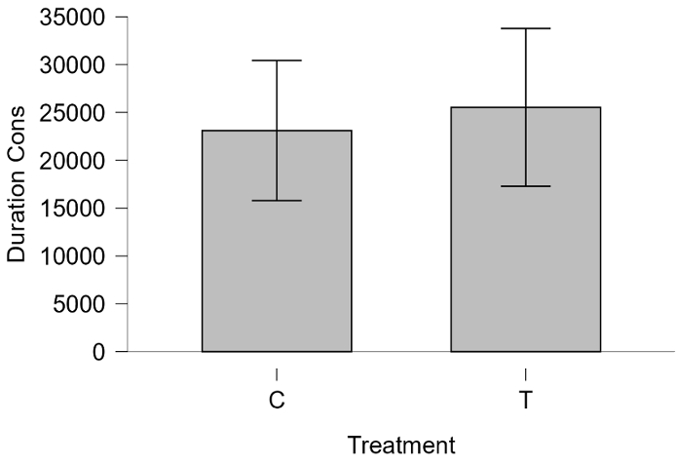

Figure 1.2: Average duration (milliseconds) spent gazing at Conservative content.

The second hypothesis states that:

H2: If an individual self-identifies with a particular partisanship, then they will avoid gazing at opposing political content.

To determine the accuracy of this prediction, a paired samples t-test was conducted to assess the difference in duration between Conservative participants and NDP participants. The first test examined all participants who self-identified with Conservative partisanship. With a total of 5 out of 17 participants self-identifying with Conservative partisanship, the average duration of visual engagement towards either NDP or Conservative content is added across both treatment and control groups. Figure 2.1 shows the average duration of time that only Conservative participants gazed at NDP content was 28,334 milliseconds. The average time spent gazing at Conservative content was 20,145 milliseconds. (See Appendix 6 for more info). Meaning, the Conservative participants in this study spent 8,189 seconds more looking at NDP content. The p-value for this is 0.02 making it highly statistically significant for a small exploratory sample.
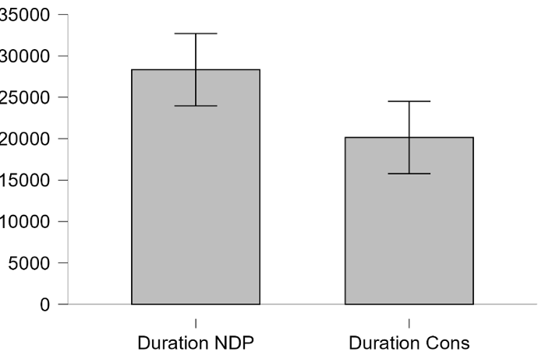

Figure 2.1: Average duration (milliseconds) that Conservative only participants spent gazing at NDP and Conservative content.

The second test examined all participants who self-identified with NDP partisanship. With a total of 9 out of 17 participants self-identifying with NDP partisanship, the average length of visual exposure to either NDP or Conservative content across both treatment groups did not differ greatly. Figure 2.2 shows that an average of 27,913 milliseconds was spent gazing at NDP content. While 27,163 milliseconds were spent focusing on Conservative content. (See Appendix 7 for more info). The p-value for this test is 0.66 meaning the data did not support the belief that this led to selective avoidance. Therefore, evidence shows that NDP only participants did not have a tendency to avoid gazing at opposing party content.

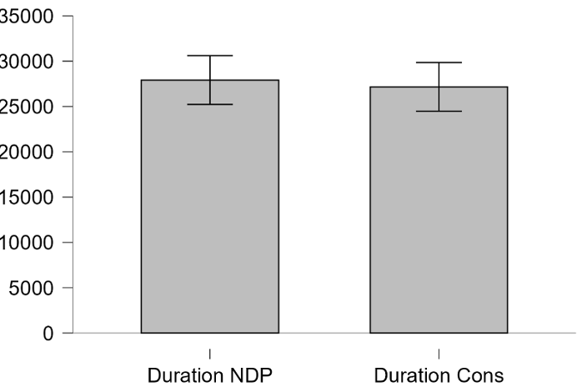

Figure 2.2: Average duration (milliseconds) that NDP only participants spent gazing at NDP and Conservative content.

Overall, findings for the second hypothesis show that the inverse effect is present, where those who identified with a particular political party spent more time visually directed at opposing party content. This was only true for those who self-identified with Conservative partisanship seeing as NDP participants did not show evidence of this effect. The eye-tracking data showed no statistically significant evidence for the prediction that partisanship leads to the selective avoidance of opposing party information. However, seeing as there is high statistical significance of Conservative partisans selectively exposing themselves to opposing content to a greater extent, it would be beneficial to explore further research on the topic of disconfirmation bias.

The presence of disconfirmation bias among participants in this study means we can reject the second hypothesis. Sude and Knobloch-Westerwick (2022) supply that individuals seek exposure to opposing information when they believe it to be “easy to refute” (p. 91). This claim is supported by the work of Ditto et al. (1998) as well as Taber and Lodge (2006). In participants who chose to visually expose themselves to opposing information to a greater extent, it is believed to be motivated by a cognitive desire to argue against the information as it is being processed. In addition, the findings of my study differed from those of Schmuck et al. who find that Conservative participants did in fact avoid gazing at attitude-discrepant political content (2019, p. 161). Whereas my research establishes the inverse effect for Conservative participants. This may be attributed to the smaller sample size as well as the use of more politically salient content. Overall, there is more to be learned about these effects and the motivations behind them.
The sub-hypothesis to the second hypothesis allows us to look at the effect of cross-cutting exposure on participants who self-identified with having somewhat weaker political party affiliations. It reads as follows:
H2a: If an individual self-identifies as having weaker ties with their chosen political party, then they will show a balanced gaze towards reaffirming and opposing content.
To assess this claim, a linear regression was performed to analyse whether participants who identified weakly with their preferred party tended to gaze evenly at the content shown. The extent of gaze duration towards NDP and Conservative content is compared to determine whether there is evidence of this hypothesis.
Figure 2.3 is a model of the span of time focusing on NDP content based on partisanship strength. In summary, 9 total participants identified as NDP, 5 total participants were Conservative, 1 identified as Green, and 2 specified that they did not know. Out of the total NDP participants, 2 stated having weaker party affiliations. Similarly, Conservative participants also had 2 who stated weaker party ties. (Refer to Appendix 8 for more info). Figure 2.3 shows that those who identified as weak NDP spent 22,294 milliseconds gazing at NDP content with a p-value of 0.96. Whereas those who identified as weak Conservatives spent 21,520 milliseconds gazing at NDP content with a p-value of 0.90. (Refer to Appendix 9 for more info). While this shows that a relatively close duration of time is spent on NDP content by both weak NDP and weak Conservative participants, it is not statistically significant under conventional standards.
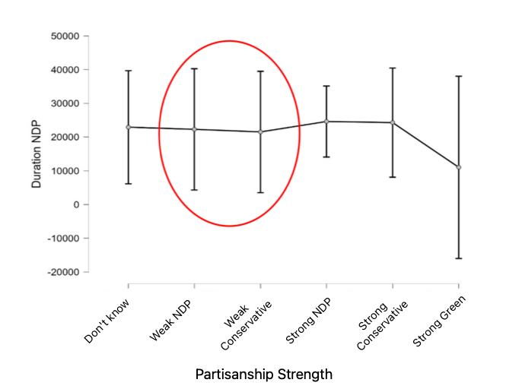

Figure 2.3: Average duration (milliseconds) that participants spent gazing at NDP content.
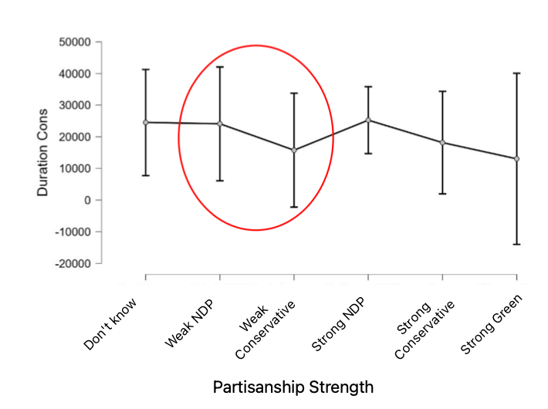
Figure 2.4 shows the duration of time that participants spent observing conservative content based on the strength of their partisanship. Those who identified as weak NDP spent 24,094 milliseconds gazing at Conservative content with a p-value of 0.97. While participants who identified as weak Conservatives spent an average duration of 15,756 milliseconds gazing at Conservative content with a p-value of 0.45. (Refer to Appendix 10 for more info). It appears that weaker NDP participants spent a total of 1,800 milliseconds less engaging with NDP content when compared to Conservative content. Results also show that weaker Conservative participants spent a total of 5,764 milliseconds less time gazing at Conservative content when compared to NDP content. The outcome of these tests is not statistically significant; therefore, conclusions cannot be drawn to confirm whether there is evidence of the sub-hypothesis. Heat map visualizations found in Appendix 11 are supplicated to show that there are also no visually significant effects of cross-cutting exposure in creating a more balanced gaze towards reaffirming and opposing viewpoints among weaker partisans.

Figure 2.4: Average duration (milliseconds) that participants spent gazing at Conservative content.
Finally, balance tests were carried out to confirm that there were no statistically significant differences between participants in the treatment and control groups. The results of these tests found no apparent differences among participants in terms of age, political interest, left-right orientation, program, and partisanship. However, there was a slight difference among the gender of participants, with significantly more women in the treatment group than the control group. (For a more detailed overview, refer to Appendix 12).
Conclusion
Ultimately, this research aimed to investigate whether there is a causal relationship between partisanship and the tendency to avoid looking at content from the opposing political party, a pattern that has been suggested in previous studies. It determined that people are not naturally inclined to read politically polarized content with a leftward bias in their visual attention. This study also established that, depending on partisanship, some people are significantly inclined to direct their focus on opposing political information as a form of disconfirmation bias. Finally, no significant effects were found to show that those with weaker ties to their preferred party had a balanced gaze across all political content through cross-cutting exposure.
There are some limitations to consider in this research. The first limitation is that only areas of interest were analysed, so I did not examine the specific words on the documents shown that may have contributed to the observed confirmation bias. This may be of interest to future researchers looking to examine the type of political speech that leads to visual avoidance or adherence to certain party content. Another limitation is that this study did not present additional content to participants other than drug policy initiatives from BC’s three main political parties. Perhaps results would have differed by showing that visual avoidance is evident in partisans when presented with reaffirming and opposing political content on alternative issues.
Furthermore, recruitment efforts were centralized at SFU Burnaby where the experiment took place which could indicate a limitation. However, although participants were not sourced from external locations, their demographics showed that they lived in various cities across BC’s Lower Mainland. A final limitation considered is that participant ages remained close in range with the average age being 19.82 (See Appendix 3 for more info). Since the sample is primarily composed of individuals from a similar age group - university students - the results may not accurately reflect the behaviours or attitudes of older or more diverse populations. Greater variety in the age distribution of participants could offer a broader perspective on the studied phenomenon.
Additionally, the post-experiment questionnaire results showed that when asked about which party policy they most approved of, approximately 48% of all participants favoured the Green party policy. Conversely, when asked about which policy they least approved of, 40% of total participants did not favour the Conservative party’s drug policy initiatives. (See Appendix 13). These results reflect a clear divergence in policy approval, highlighting how exposure to differing viewpoints improves understanding and knowledge towards such a widespread issue.
The findings of this research therefore emphasize the influence of partisan bias and suggest that targeted interventions be implemented by policymakers to encourage more balanced engagement with political information. Such efforts could ease polarization, creating a more informed society, thus strengthening democratic engagement and support for more effective solutions to complex societal issues such as the opioid crisis.

REFERENCES
Areal, J. (2024). Beyond disdain: Measurement and consequences of negative partisanship as a social identity. Electoral Studies, 90, https://doi.org/10.1016/j.electstud.2024.102831
BC Emergency Health Services. (2025). Overdose & drug poisoning data. Provincial Health Services Authority. https://www.bcehs.ca/about/accountability/data/overdose-drug-poisoning-data#Key--findings--2024
Belzak, L., & Halverson, J. (2018). Evidence synthesis- The opioid crisis in Canada: A national perspective. Health Promotion and Chronic Disease Prevention in Canada, 38(6), 224-233. https://doi.org/10.24095/hpcdp.38.6.02.
Bode, L., Vraga, E. K., & Troller-Renfree, S. (2017). Skipping politics: Measuring avoidance of political content in social media. Research & Politics, 4(2), 2053168017702990. https://doi.org/10.1177/2053168017702990.
Churches, O., Loetscher, T., Thomas, N. A., & Nicholls, M. E. R. (2017). Perceptual biases in the horizontal and vertical dimensions are driven by separate cognitive mechanisms. Quarterly Journal of Experimental Psychology, 70(3), 444–460. https://doi.org/10.1080/17470218.2015.1131841
Dickson, C., Kurjata, A., & Zeschky, J. (2024). How do British Columbia’s three main parties compare on these election issues? CBCnews. https://newsinteractives.cbc.ca/features/2024/british-columbia-party-platforms/#intro
Dickinson, C. A., & Intraub, H. (2009). Spatial asymmetries in viewing and remembering scenes: Consequences of an attentional bias? Attention, Perception & Psychophysics, 71(6), 1251–1262. https://doi.org/10.3758/APP.71.6.1251.
Ditto, P. H., Scepansky, J. A., Munro, G. D., Apanovitch, A. M., & Lockhart, L. K. (1998). Motivated Sensitivity to Preference-Inconsistent Information. Journal of Personality and Social Psychology, 75(1), 53–69. https://doi.org/10.1037/0022-3514.75.1.53.
Garrett, R. K. (2009). Politically Motivated Reinforcement Seeking: Reframing the Selective
Exposure Debate. Journal of Communication, 59(4), 676–699. https://doi.org/10.1111/j.1460-2466.2009.01452.
Greene, S. (2002). The Social-Psychological Measurement of Partisanship. Political Behavior, 24(3), 171–197. https://doi.org/10.1023/A:1021859907145
Hart, W., Albarracín, D., Eagly, A. H., Brechan, I., Lindberg, M. J., & Merrill, L. (2009). Feeling validated versus being correct: a meta-analysis of selective exposure to information. Psychological bulletin, 135(4), 555–588. https://doi.org/10.1037/a0015701.
Jang, S. M. (2014). Challenges to Selective Exposure: Selective Seeking and Avoidance in a Multitasking Media Environment. Mass Communication & Society, 17(5), 665–688. https://doi-org.proxy.lib.sfu.ca/10.1080/15205436.2013.835425.
Klar, S. (2014). Partisanship in a Social Setting. American Journal of Political Science, 58(3), 687–704. https://doi.org/10.1111/ajps.12087.
Knobloch-Westerwick, S. (2015). Choice and Preference in Media Use: Advances in Selective Exposure Theory and Research. Routledge.
Lelkes, Y., & Westwood, S. J. (2017). The limits of partisan prejudice. The Journal of Politics, 79(2), 485–501. https://doi.org/10.1086/688223
Matthes, J., & Marquart, F. (2015). A New Look at Campaign Advertising and Political Engagement: Exploring the Effects of Opinion-Congruent and -Incongruent Political Advertisements. Communication Research, 42(1), 134–155. https://doi.org/10.1177/0093650213514600.
Matthes, J., Knoll, J., Valenzuela, S., Hopmann, D. N., & Von Sikorski, C. (2019). A Meta- Analysis of the Effects of Cross-Cutting Exposure on Political Participation. Political Communication, 36(4), 523–542. https://doi.org/10.1080/10584609.2019.1619638
Mutz, D. C. (2002a). The Consequences of Cross-Cutting Networks for Political Participation. American Journal of Political Science, 46(4), 838–855. https://doi.org/10.2307/3088437
Mutz, D. C. (2002b). Cross-Cutting Social Networks: Testing Democratic Theory in Practice. The American Political Science Review, 96(1), 111–126. http://www.jstor.org/stable/3117813
Ohme, J. (2021). Algorithmic social media use and its relationship to attitude reinforcement and issue-specific political participation – The case of the 2015 European immigration movements. Journal of Information Technology & Politics, 18(1), 36–54. https://doi.org/10.1080/19331681.2020.1805085
Peterson, E., & Kagalwala, A. (2021). When Unfamiliarity Breeds Contempt: How Partisan Selective Exposure Sustains Oppositional Media Hostility. American Political Science Review, 115(2), 585–598. https://doi.org/10.1017/S0003055420001124.
Segijn, C. M., & Vraga, E. (2024). Eye tracking. In P. Neijens, T. Araujo, J. Möller, & C. H. de Vreese, Measuring exposure and attention to media and communication. Solutions to wicked problems (pp. 113-127). Amsterdam University Press. https://doi.org/10.5117/9789463723176_ch07.
Stroud, N. J. (2007). Media use and political predispositions: Revisiting the concept of selective exposure. Political Behavior, 30(3), 341–366. https://doi.org/10.1007/s11109-007-9050-9.
Sude, D., & Knobloch-Westerwick, S. (2022). Selective exposure and attention to attitude- consistent and attitude-discrepant information: Reviewing the evidence. Knowledge resistance in high-choice information environments, 88-105. Routledge. https://doi.org/10.4324/9781003111474-5.
Sülflow, M., Schäfer, S., & Winter, S. (2019). Selective attention in the news feed: An eye-tracking study on the perception and selection of political news posts on Facebook. New Media & Society, 21(1), 168–190. https://doi.org/10.1177/1461444818791520/
Taber, C. S., & Lodge, M. (2006). Motivated Skepticism in the Evaluation of Political Beliefs. American Journal of Political Science, 50(3), 755–769. https://doi.org/10.1111/j.1540-5907.2006.00214.x
Xenos, M., Scheufele, D., Brossard, D., Choi, D., Cacciatore, M., Yeo, S., & Su, L. (2018). News Media Use and the Informed Public in the Digital Age. International Journal Of Communication, 12, 19. https://ijoc.org/index.php/ijoc/article/view/5425/2262

APPENDIX 1
The following images contain screenshots of the Pre-Experiment questionnaire presented to participants:
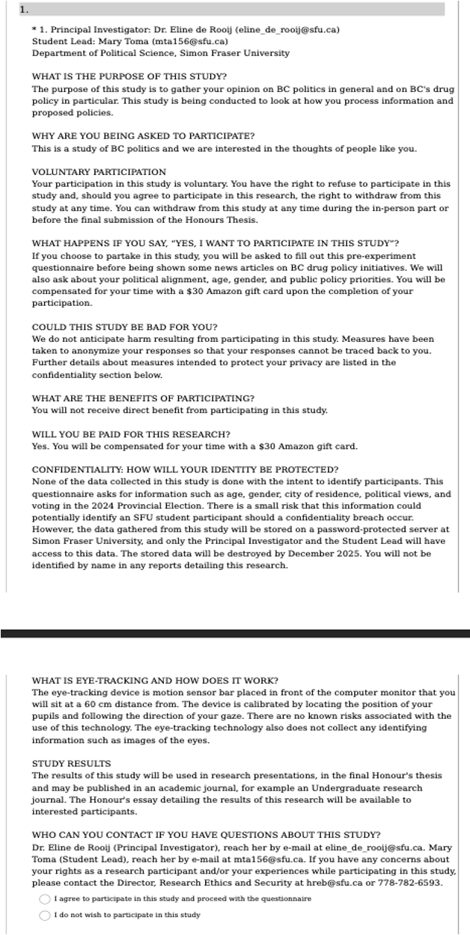

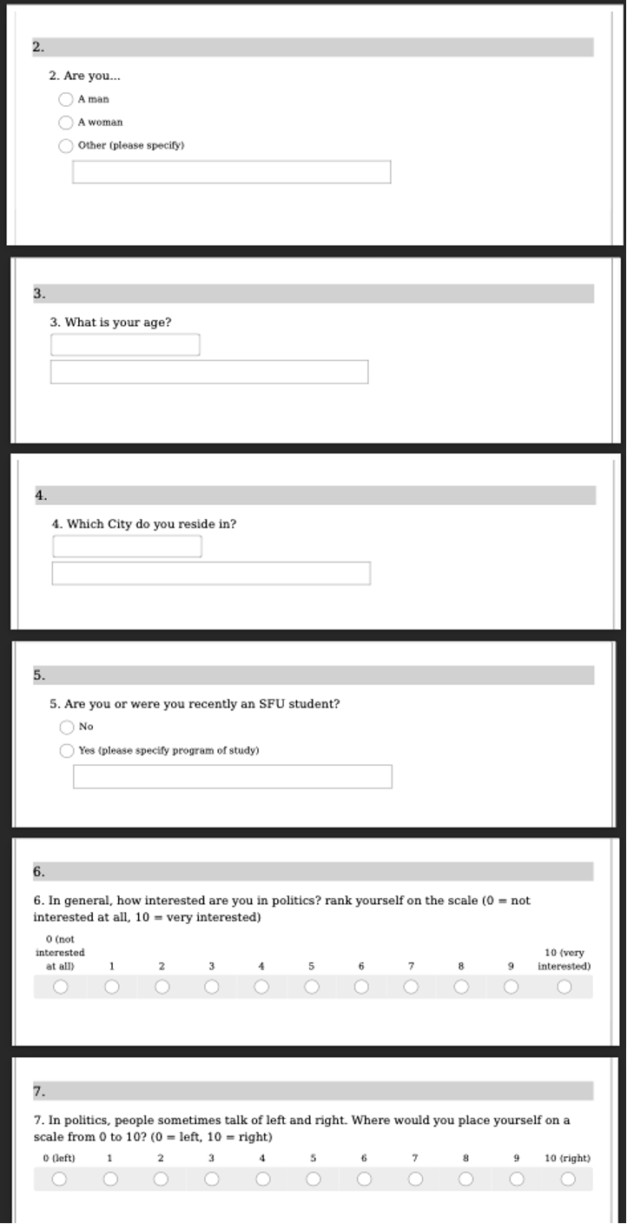

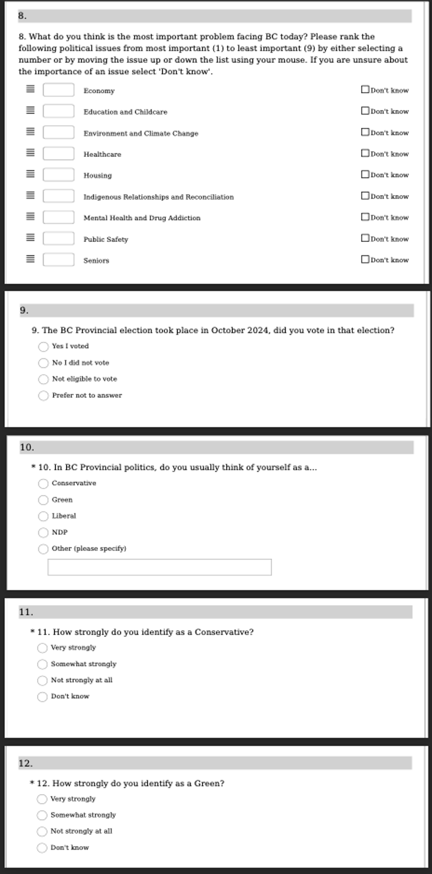
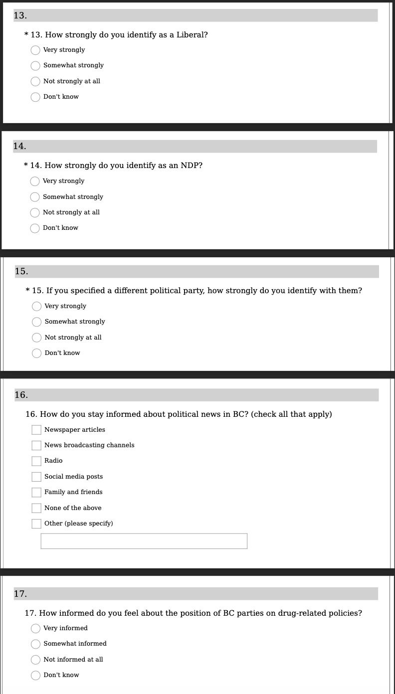

APPENDIX 2
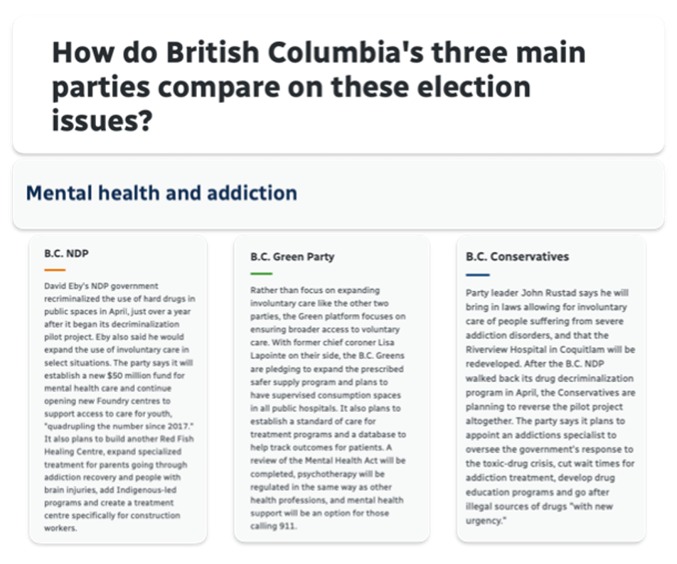
The first image where NDP appears on the left and Conservative appears on the right is an example of the treatment document shown to participants:

Image 1: Treatment document

The second image where NDP appears on the right and Conservative appears on the left is an example of the control document shown to participants:
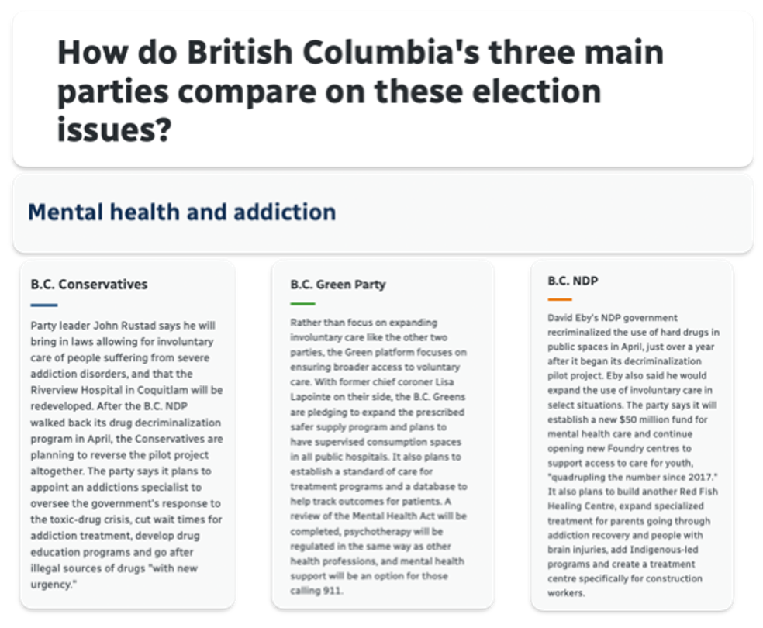
Image 2: Control document

APPENDIX 3
Frequencies for Program
Program |  | Frequency |  | Percent (%)
Beedie School of Business |  | 2 |  | 11.76
Criminology |  | 3 |  | 17.65
French Cohort |  | 1 |  | 5.88
Interactive Arts and Technology |  | 1 |  | 5.88
International Studies |  | 1 |  | 5.88
Kinesiology |  | 1 |  | 5.88
Molecular Biology and Biochemistry |  | 1 |  | 5.88
Physics |  | 1 |  | 5.88
Political Science |  | 5 |  | 29.41
Psychology |  | 1 |  | 5.88
Total |  | 17 |  | 100.00
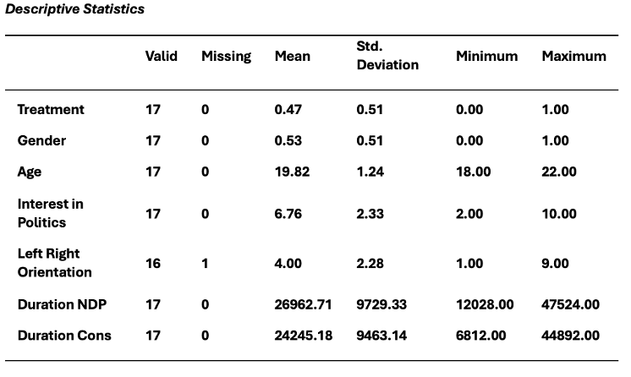

APPENDIX 4
The following statistics contain an independent sample t-test comparing the gaze duration (milliseconds) towards NDP content in treatment and control groups.
 |  | t |  | Df |  | p
Duration NDP |  | -1.58 |  | 15 |  | 0.14

 |  | Group |  | N |  | Mean |  | SD |  | SE |  | Coefficient of variation
Duration NDP |  | C |  | 9 |  | 23602.44 |  | 7676.42 |  | 2558.81 |  | 0.33
 |  | T |  | 8 |  | 30743.00 |  | 10870.60 |  | 3843.34 |  | 0.35

N = 17

APPENDIX 5
The following statistics contain an independent sample t-test comparing the gaze duration (milliseconds) towards Conservative content in treatment and control groups.
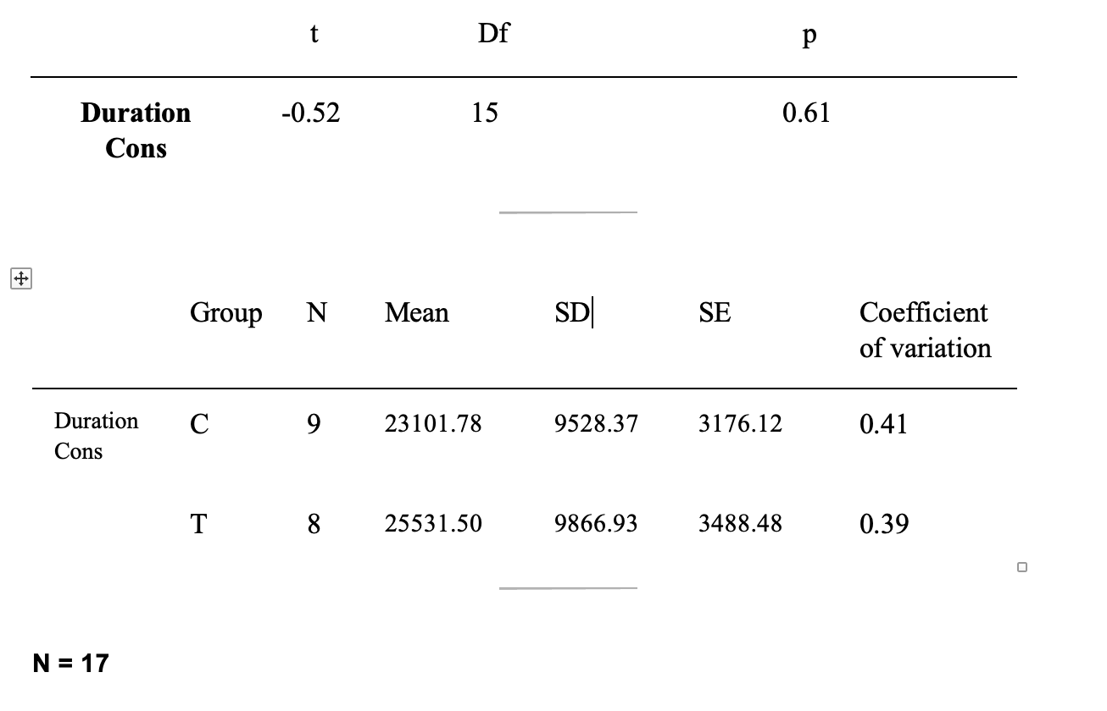

APPENDIX 6
The following statistics are a result of the paired samples t-test used to determine the duration of time (milliseconds) that Conservative only participants spent gazing at NDP or Conservative content across both treatment groups. For reference, the heat map visualization offered below shows where Conservative participants in the control group focused more of their visual attention towards.
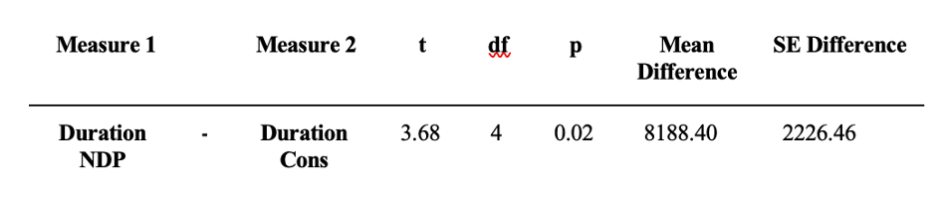
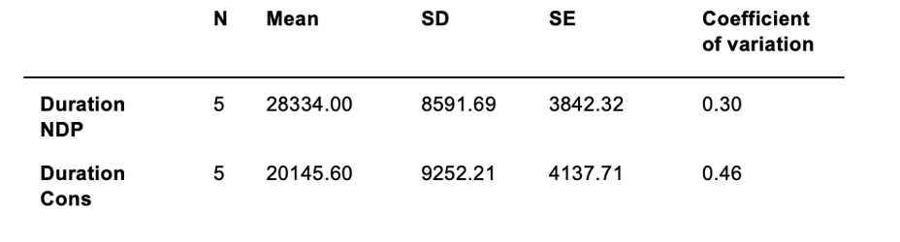
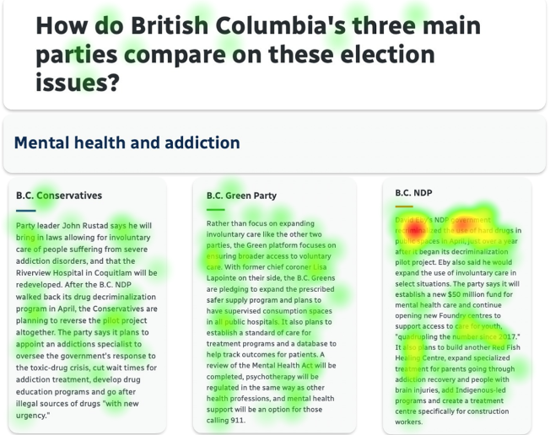

APPENDIX 7
The following statistics are a result of the paired samples t-test used to determine the duration of time (milliseconds) that NDP only participants spent gazing at NDP or Conservative content across both treatment groups.
Measure 1 |  |  |  | Measure 2 |  | t |  | df |  | p |  | Mean Difference |  | SE Difference
Duration NDP |  | - |  | Duration Cons |  | 0.46 |  | 8 |  | 0.66 |  | 750.22 |  | 1648.18

 |  | N |  | Mean |  | SD |  | SE |  | Coefficient of variation
Duration NDP |  | 9 |  | 27913.78 |  | 11457.71 |  | 3819.24 |  | 0.41
Duration Cons |  | 9 |  | 27163.56 |  | 10408.63 |  | 3469.54 |  | 0.38

APPENDIX 8
Frequencies for Partisanship
Partisanship |  | Frequency |  | Percent
NDP |  | 9 |  | 52.94
Conservative |  | 5 |  | 29.41
Green |  | 1 |  | 5.88
Other |  | 2 |  | 11.76
Total |  | 17 |  | 100.00

Frequencies for Partisanship Strength
Partisanship Strength |  | Frequency |  | Percent
Don't know |  | 2 |  | 11.76
Weak NDP |  | 2 |  | 11.76
Weak Conservative |  | 2 |  | 11.76
Strong NDP |  | 7 |  | 41.18
Strong Conservative |  | 3 |  | 17.65
Strong Green |  | 1 |  | 5.88
Total |  | 17 |  | 100.00

APPENDIX 9
The following tables contain descriptions of the average duration of time (milliseconds) spent gazing at NDP content based on the strength of partisanship across both treatment groups.
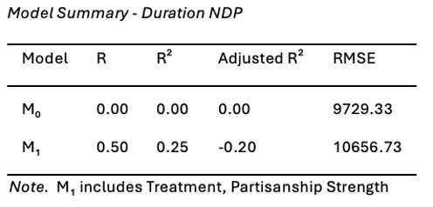
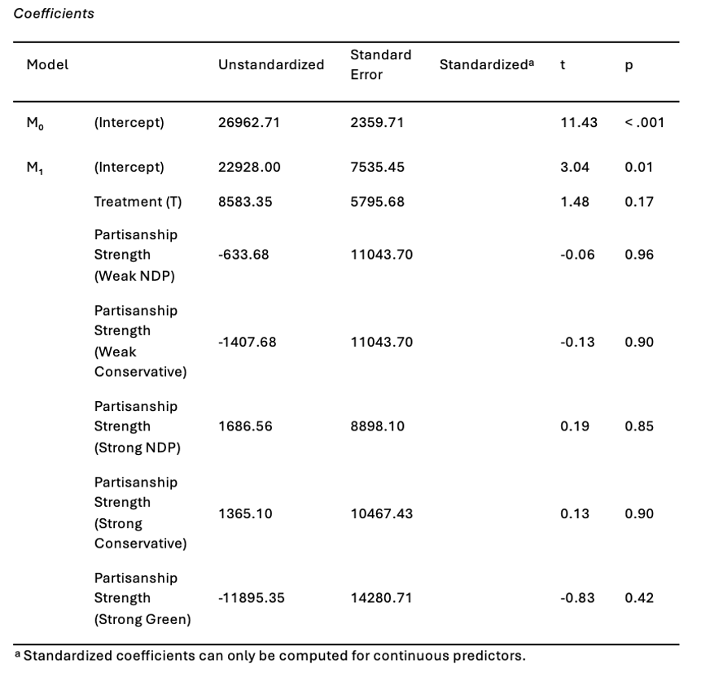

APPENDIX 10
The following tables contain descriptions of the average duration of time (milliseconds) spent gazing at Conservative content based on the strength of partisanship across both treatment groups.
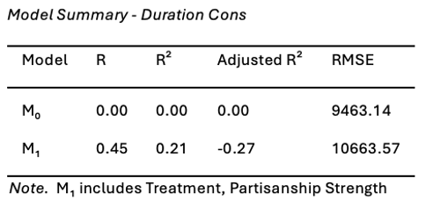
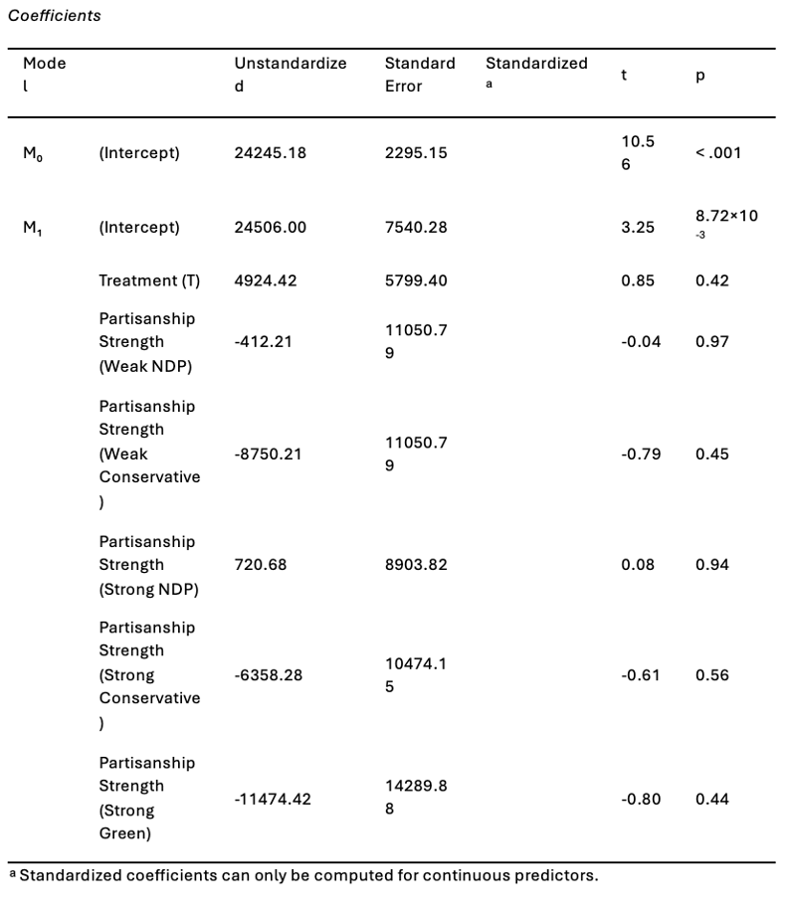

APPENDIX 11
Heat map visualizations showed no significant effects of cross-cutting exposure leading to a more balanced gaze among participants with weaker partisanship across the two treatment conditions.
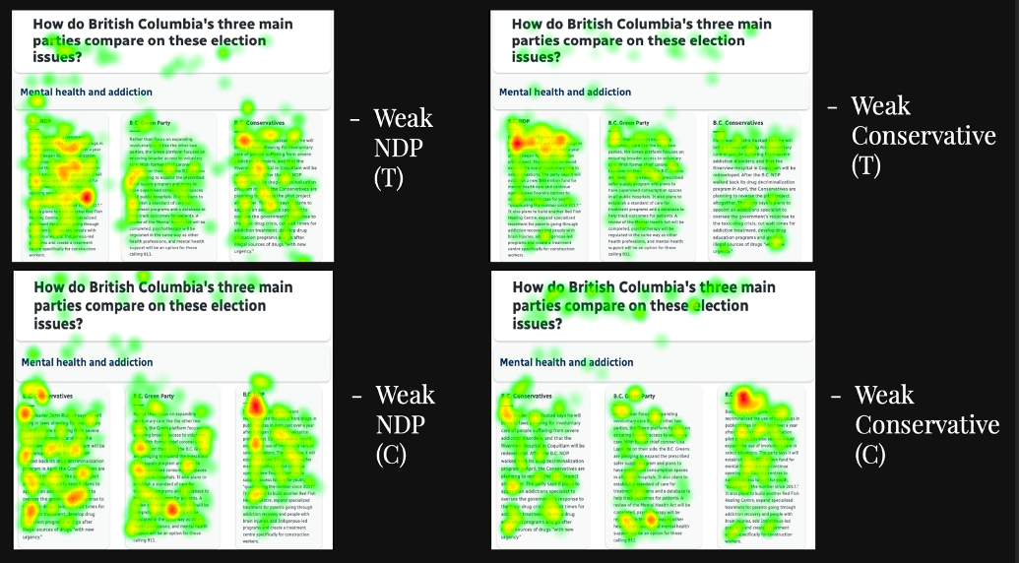

APPENDIX 12
The only balance test indicating a significant difference between the treatment and control group was for gender with a p-value of 0.10. More women were found to be in the treatment group compared to the control group.
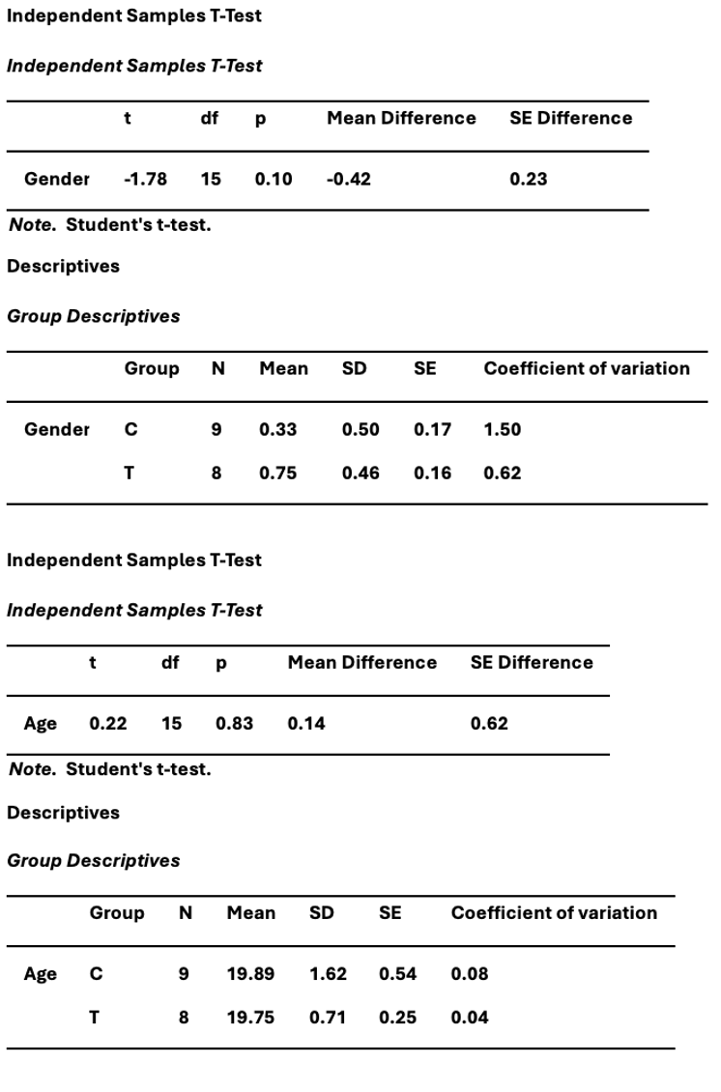
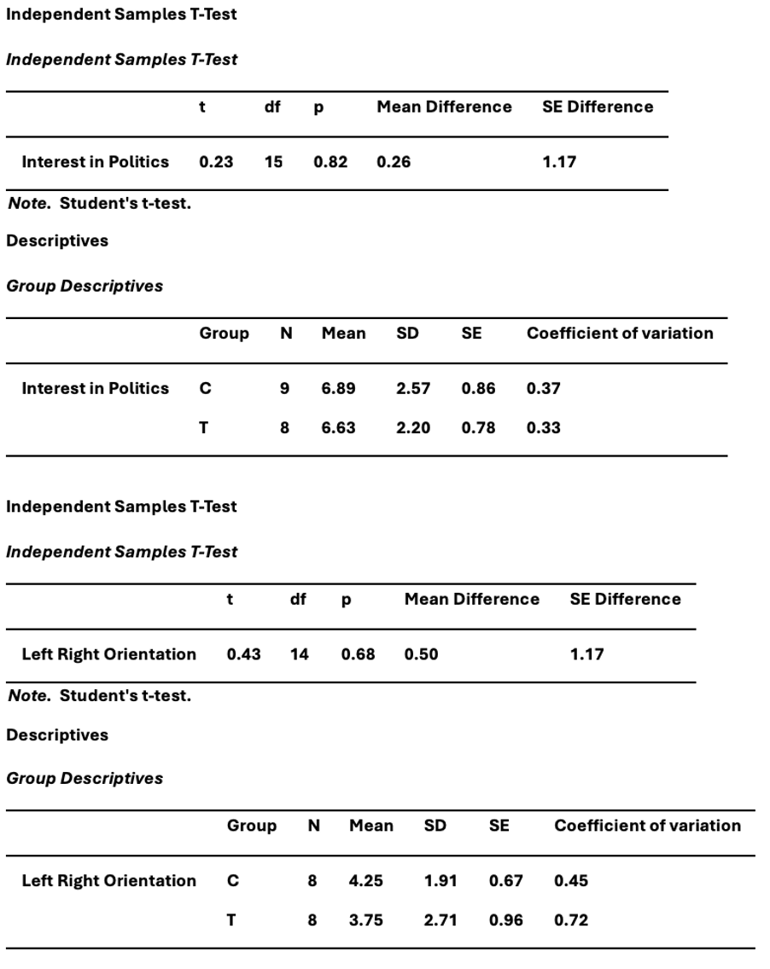

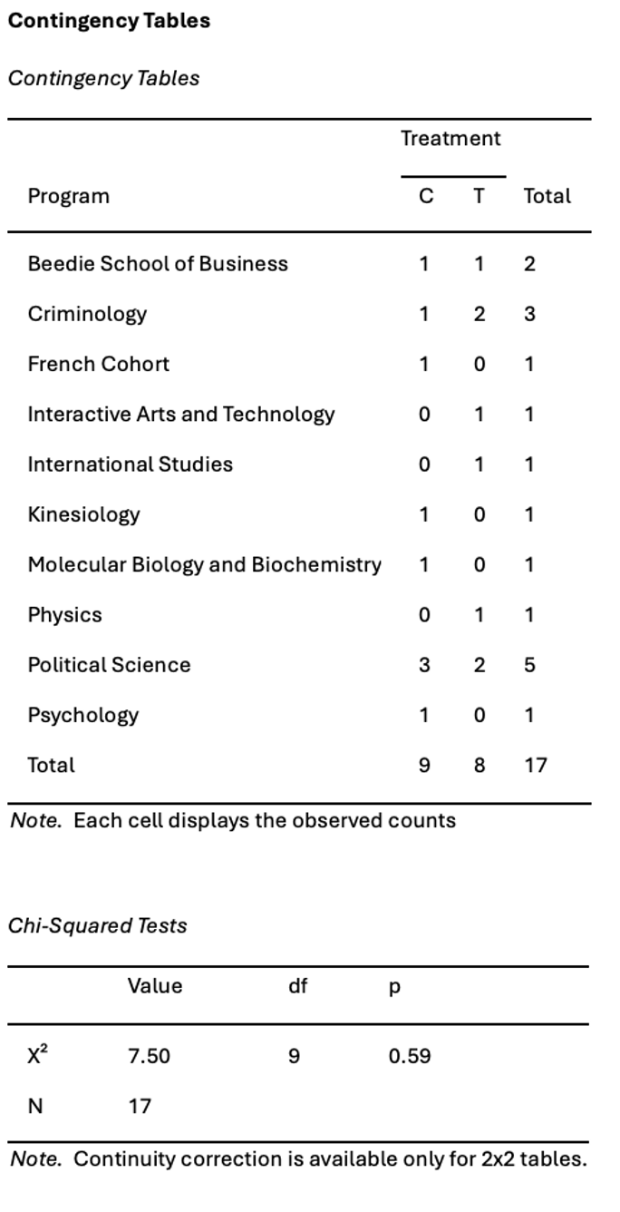
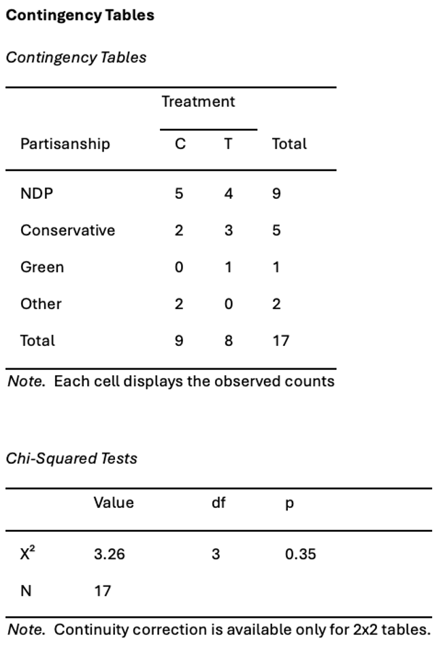

APPENDIX 13
Bar graph from SurveyMonkey results of post-experiment questionnaire.
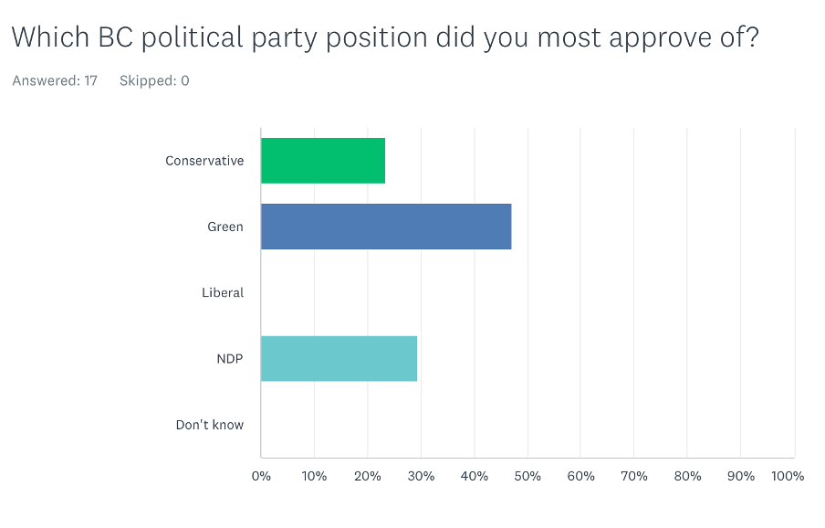
N = 17

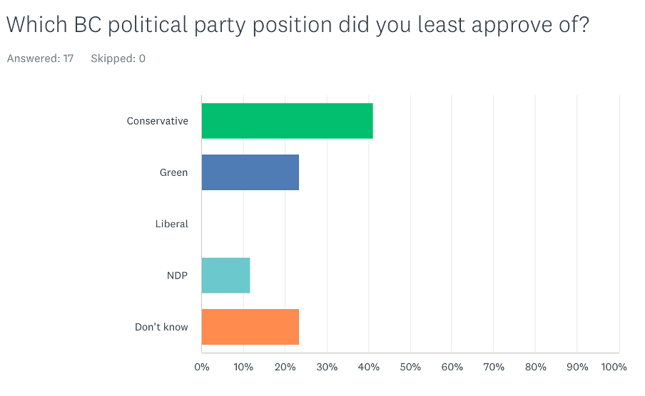
N = 17

