Governance and Global Power

| Power, Proximity, and Priorities: Unpacking China’s Belt and Road Investments
Ideja Efendija
Keywords: Belt and Road Initiative, Chinese foreign policy, East Asia, infrastructure diplomacy, geopolitical strategy, international development
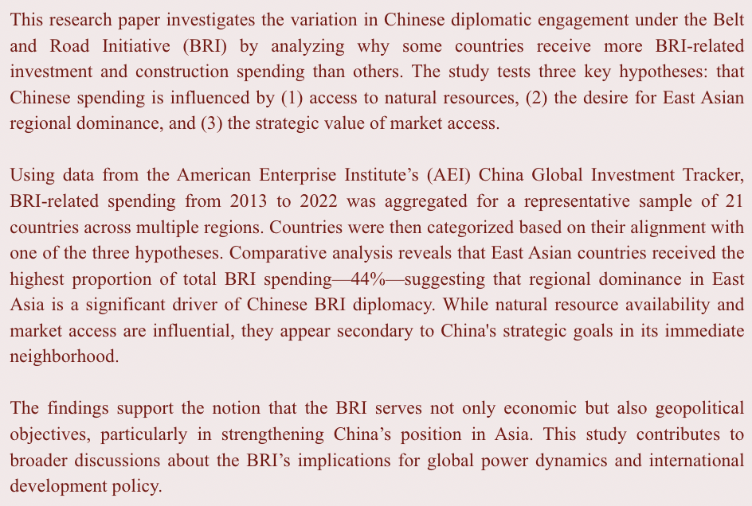

Introduction
The Belt and Road Initiative (BRI), announced by Xi Jinping in 2013 during his visits to Kazakhstan and Indonesia, is a vast collection of infrastructure and development projects spanning from East Asia to Europe. The initiative consists of two primary components: the ‘Silk Road Economic Belt’ and the ‘Maritime Silk Road’. The Silk Road Economic Belt comprises of a network of land-based infrastructure projects that extends from China through Central Asia to Europe. According to The State Council Information Office of the People's Republic of China website, this portion of the BRI consists of the construction of six international economic corridors: China-Mongolia-Russia Economic Corridor (CMREC), New Eurasian Land Bridge (NELB), China-Central Asia-West Asia Economic Corridor (CCWAEC), China-Indochina Peninsula Economic Corridor (CICPEC), China-Pakistan Economic Corridor (CPEC), and the Bangladesh-China-India-Myanmar Economic Corridor (BCIMEC).
The Maritime Silk Road (MSR) includes several port and coastal infrastructure projects in South-East Asia, East Africa, and the Mediterranean. However, while that was the initial plan, the BRI has expanded to include countries beyond its initial scope with numerous Latin American countries joining the BRI in recent years. As of July 2022, 147 countries were participating in the entire [A1] BRI, according to the Green Finance & Development Center.

With the BRI, Beijing aimed to revitalize the sluggish Chinese economy by developing new markets for Chinese goods. Furthermore, it was also meant to help offload excess industrial capacity. On top of these domestic, pragmatic goals of the BRI, it also aims to increase economic cooperation and integration. As outlined in the BRI Action Plan, Beijing aims to revive the “Silk Road Spirit” that emphasises “peace and cooperation, openness and inclusiveness, mutual learning and mutual benefit.” The initiative’s key cooperation priorities include “policy coordination, facilities connectivity, unimpeded trade, financial integration, and people-to-people bond.” The BRI has now become a centerpiece to Xi Jinping’s foreign policy and is a physical manifestation of China’s growing role on the world stage.
As part of the initiative, Beijing coordinates with different countries on infrastructure projects they require, often through bilateral diplomatic meetings. China and the recipient country then sign a memorandum of understanding (MOU) once talks are completed. The projects range from highway and railroad construction to port development. It even extends to the construction of Special Economic Zones (SEZs) and energy developments. Once areas of infrastructure and investment are identified, Chinese State-Owned Enterprises (SOEs) will help build these projects, often employing Chinese laborers.
The implementation of BRI projects varies significantly between countries, both in scale and focus. Some nations receive extensive Chinese investment, while others receive comparatively little. This discrepancy raises an important research question: Why does Chinese diplomacy surrounding the Belt and Road Initiative vary from country to country?
This paper seeks to explain the variation in BRI-related infrastructure and investment by comparing Chinese spending across 21 recipient countries. It will explore three hypotheses informed by both official Chinese objectives and scholarly interpretations of the BRI’s underlying motivations.
Beijing has largely focused on the mutual benefit features of the BRI and has presented it as a “win-win” situation for both China and the recipient country. However different scholars, thinktanks, and organizations have put forward their own explanations for the BRI that go beyond the ones stated by China. This paper first reviews the academic literature on the unofficial motivations behind the BRI. Then, building on that foundation, it formulates three testable hypotheses that will be evaluated using data from a sample of 21 BRI recipient countries. By doing so, this study aims to contribute to our understanding of how BRI-related diplomacy manifests differently across countries.
The BRI is important to discuss as it is a key mechanism through which China expands economic and political influence. Numerous western powers, notably the United States (US) and the European Union (EU), are concerned about the expansion of China’s influence and see it as a bid for China to alter the current geopolitical landscape. The BRI has influenced and will continue to influence the international world order. One consequence of the BRI’s rise is the emergence of rival initiatives, such as the United States’ Build Back Better World Initiative. By investigating the drivers of China’s varied BRI engagement, this study enhances our understanding of a major force influencing today’s global political economy. Evidently, the BRI has influenced how foreign aid is distributed. An investigation into what informs Chinese diplomacy surrounding different BRI projects will enrich the scholarship on such a prominent project in today’s geopolitical climate.

Existing Literature
This specific research question has been relatively under-explored. There are no studies that compare the spending for BRI projects to explain what determines the variation of Chinese diplomacy in various BRI-recipient countries. However, there is a substantial body of literature on the motivations and strategies behind the BRI that go beyond China’s stated goals of increased economic cooperation.
China has frequently been criticized for the BRI. One of the most prominent criticisms comes from some scholars, like Carrai, Alam and Asef, who argue that China is engaging in ‘debt-trap diplomacy’ whereby China leverage the power imbalance present between them and BRI recipient countries to issue loans that are too high to pay back to help countries build their infrastructure projects with the intention of gaining strategic concession upon failure to repay these loads. Carrai’s argument was largely based on the infamous Sri Lanka case in which China took control of the deep-sea Hambantota International Port in a 99-year lease after Sri Lanka failed to pay their debts, leaving Sri Lanka’s government with only “residual sovereignty over that territory.”
However, other scholars like Deborah Brautigam, Kevin Acker, and Yufan Huang have pushed back against this interpretation and largely discredited this stance. Their research shows that the Sri Lanka port case was not debt-trap diplomacy by explaining that Chinese banks did not seize the port from Sri Lanka and that they are willing to restructure the terms of the loans. Brautigam and several other scholars also debunked rumors that Kenya had staked the Mombasa Port as collateral for the Chinese loans used to build the Standard Gauge Railway (SGR). Through reconstruction of the contractual arrangements, they showed that this misunderstanding originated from Kenya’s Auditor General mislabelling the Kenya Port Authority as a “borrower, responsible for repaying the SGR loans.
Another form of pushback against the idea of “debt-trap diplomacy” comes from some Think Tanks, like Chatham house, who emphasize the role of the recipient country in shaping the BRI projects as they are built through multiple bilateral meetings. Additionally, they posited that China’s development financing system is “too fragmented and poorly coordinated to pursue the detailed strategic objectives they have been accused of. Nevertheless, the image of the BRI remains entangled with the “debt-trap diplomacy” narrative.
Furthermore, some pundits from the Asia Society, Daniel R. Russel and Blake H. Berger have warned about the military strategy behind the BRI. They posit that the BRI projects, specifically the ports being built along the Maritime Silk Road may serve future military purposes, despite China’s denial of these claims. These ports act as “strategic strongpoints” that can increase the support provided to the People’s Liberation Army (PLA) forces operating abroad. To supplement their position, they highlight the economic underperformance of ports in Sri Lanka and Pakistan, suggesting that the absence of profitability underscores their strategic value over their commercial one. Similarly, other scholars, such as John Mearsheimer, have argued similar geostrategic motivations suggesting that the BRI is part of China’s strategy to achieve East Asian dominance and US exclusion in Asia by consolidating their position in the region.
What remains missing in these discussions, however, is an analysis of how these various motivations influence the level of Chinese investment across BRI-recipient countries. This project will add to these debates by bridging the aims of the BRI that have been put forward by pundits to the way in which these aims influence how the BRI policy manifests itself in different countries. It also evaluates which of these aims are most clearly reflected in reality.

Methodology
To investigate the research question, this study compares Chinese BRI-related spending in construction and investment in a sample of 21 BRI recipient countries in order to determine the countries receiving the highest Chinese spending. The central assumption made in this research is that the more Chinese spending a country receives, the greater diplomatic and strategic commitment to that country. Given the evolving nature of the BRI, including recent extensions into space cooperation, this study focuses on a fixed, diverse sample to ensure analytical depth and geographic balance.
Sample Selection
The countries chosen represent all major regions (East Asia, South America, Africa, Europe, Middle East) in which China has invested in as part of the BRI to ensure a representative sample. The sample includes Cambodia, Singapore, the Philippines, Laos, Indonesia, Malaysia, Vietnam, Greece, Kenya, Pakistan, Djibouti, Egypt, Turkey, Bangladesh, Algeria, Russia, Angola, Oman, UAE, Chile, and Bolivia.
The raw data used in this research comes from the China Global Investment Tracker data collected by the American Enterprise Institute (AEI). This source has been chosen as it is the “only comprehensive public data set covering China’s global investment and construction.” Using this data, the following testable hypotheses will be investigated:

Hypothesis 1
The natural resources a country provides influences Chinese engagement and commitment under the BRI, resulting in higher spending in those countries.
Natural resources such as oil and energy are vital to China. One of Beijing’s main priorities is to ensure a sustainable energy supply to work towards their goal of “becoming a strong and prosperous society by 2049” For this hypothesis to be true, the investigation will demonstrate an increase in the spending on Chinese investment and infrastructure to countries that provide natural resources.
From the sample, the countries with natural resources have been identified as:
- Algeria, for its abundance of oil and for being a leading exporter of oil and petroleum to China. The flagship infrastructure projects part of the BRI in Algeria are the East-West Highway which connects Algeria to Morocco and Tunisia, and the development of the El Hamdania Central Port, set to become Algeria’s first deep-water port.
- Russia, for its abundance of energy. Despite Russia’s presence in two of the six BRI economic corridors, the main area of cooperation between the two countries has been energy. This is reflected by the two flagship BRI projects in Russia: the Power of Siberia Natural Gas Pipeline, which is set to supply 38 billion cubic meters of natural gas to China annually for 30 years and the Yamal Liquefied Natural Gas Project.
- Angola, for its abundance of oil. Chinese loans been used to construct roads, bridges, power plants, and hospitals. Most importantly, the Caculo-Cabaça Hydropower Station was built by Chinese SOEs as part of the BRI.
- Oman for its abundance of energy. Chinese investments in Oman have focused on building the Sino-Oman industrial city and the Duqum Special Economic Zone. “According to Lu Ruquan, director of the Strategic Development Department of the China National Petroleum Corporation, Oman is China’s main energy corridor.”
- UAE for its abundance of oil. The flagship BRI projects in the UAE include the China-UAE Industrial Capacity Cooperation Demonstration Zone (ICCDZ). It also includes the new Traders Market Station.
- Chile for its abundance in lithium. The flagship project in Chile is the high-speed line that goes from the capital, Santiago, to Valparaíso.
- Bolivia similarly for its abundance in lithium. The flagship project in Bolivia is the El Espino-Boyuibe Highway Project that links Bolivia to Paraguay and Argentina. Construction includes the reconstruction of the Parapeti Bridge.
Therefore, if H1 is supported, the above listed countries should exhibit the highest levels of BRI-related spending by China.

Hypothesis 2
China’s desire for regional dominance in East Asia leads to greater diplomatic and economic engagement with East Asian countries under the BRI.
For this to be supported, we would expect to see higher BRI-related spending in East Asian countries. From the sample, the East Asian countries have been identified as:
- Cambodia. Major BRI projects include the Lower Sesan II Hydropower Plant, Phnom Penh-Sihanoukville Expressway and developments in the Sihanoukville Province. These developments include a Special Economic Zone and a deep-water port.
- Singapore. The main BRI projects in Singapore include the New International Land-Sea Trade Corridor, which connects the Chinese province of Chongqing to Singapore, and the China-Singapore Demonstration Initiative on Strategic Connectivity.
- The Philippines. The flagship projects in the Philippines include the Kaliwa Dam, overseen by the SOE Energy China, and the Chico River Pump Irrigation Project.
- Laos. The Laos-China Economic Corridor and the Laos-China High-Speed Railway, which connects Vientiane in Laos to Boten on the China-Laos border, are the key BRI projects in Laos.
- Indonesia. The flagship BRI project in Indonesia is the Jakarta-Bandung High-Speed Railway.
- Malaysia. The major BRI projects in Malaysia include the East Coast Rail Link (ECRL), the Malaysia-China Kuantan Industrial Park, and developments at the Kuantan Port.
- Vietnam. The flagship BRI projects in Vietnam are both energy related: the Dau Tieng Solar Power Project and the Nam Dinh 1 Coal Power Project.
Therefore, for H2 to be supported, these countries would receive the highest levels of BRI-related investment and infrastructure spending.

Hypothesis 3
The most important goal for the BRI is to increase trade by gaining access to new markets and thus countries that provide strategic market access will receive the highest level of BRI investment and infrastructure spending.
From the sample, the countries identified as providing the most access to new markets are:
- Greece for its access to European markets. The flagship project in Greece is the construction of the Port of Piraeus and the Piraeus Container Terminal, which became the “fourth-busiest container terminal in Europe.
- Kenya for its access to East and Central African markets. The main BRI project in Kenya is the Standard Gauge Railway (SGR) that connects the Mombasa port to Nairobi (the capital city), Naivasha, Kisumu and Malaba, a town on the Kenya-Uganda border.
- Pakistan for its access to new markets via the Indian Ocean. The flagship project in Pakistan is the China-Pakistan Economic Corridor (CPEC) that includes projects in the energy sector, transportation infrastructure, and the construction of the deep-sea port of Gwadar.
- Djibouti for its location along major international shipping corridors. The main BRI projects in Djibouti consist of the Boraleh Multipurpose Port, the Djibouti International Free Trade Zone and the Addis Ababa-Djibouti Railway which facilitates access to the Ethiopian market.
- Egypt for its critical access to global markets via the Suez Canal. The flagship projects in Egypt include the Suez Canal Economic Zone and the High-Speed Rail Line running from the Red Sea town of Ain Sokhna to the new administrative capital.
- Turkey for its access to both European and Middle Eastern markets. The main project in Turkey is the Middle Corridor Initiative that links Anatolia to Central Asia and China.
- Bangladesh for its access to South Asian markets. Two major BRI projects in Bangladesh include the Padma Bridge and the Payra Power Plant.
For H3 to be supported, these countries would show the highest levels of BRI-related investment from China.

Findings
The China Global Investment Tracker (AEI) dataset includes Chinese investment and construction spending from 2003 to 2022, including spending on projects not officially categorized under the BRI. For this research, the dataset was modified to include only BRI-related projects, with the time frame restricted to 2013-2022, starting from the year the BRI was announced. This ensures only the most relevant data is included in the analysis.
Below are three tables summarizing Chinese BRI investment and construction spending for the selected sample of 21 countries. Each country is categorized according to the hypothesis it supports. The raw data includes disaggregated spending by various SOEs; however, to simplify the analysis, the values have been aggregated to reflect total BRI-related spending per country. Detailed breakdowns can be found in Appendices A, B, and C.
Table 1 depicts Chinese spending in both investment and infrastructure in the East Asian countries identified for this research.
Table 1
EAST ASIAN COUNTRIES | BRI INVESTMENT AND  CONSTRUCTION IN US DOLLARS
Cambodia | 13,540 million
Singapore | 40,760 million
Philippines | 17,570 million
Laos | 22,520 million
Indonesia | 44,250 million
Vietnam | 14,630 million
Malaysia | 30,060 million
Total Spending: | 183,330 million
Table 2 includes Chinese spending in investment and infrastructure in the countries identified for providing market access for this research:
Table 2
TRADE & MARKET ACCESS COUNTRIES | BRI INVESTMENT AND CONSTRUCTION IN US DOLLARS
Greece | 4,210 million
Kenya | 9,370 million
Pakistan | 53,190 million
Djibouti | 1,480 million
Egypt | 16,520 million
Turkey | 5,780 million
Bangladesh | 26,420 million
Total Spending: | 116,970 million
Table 3 includes Chinese spending in investment and infrastructure in the countries identified for their abundance in natural resources for this research:

Table 3
NATURAL RESOURCE COUNTRIES | BRI INVESTMENT AND CONSTRUCTION IN US DOLLARS
Algeria | 10,750 million
Russia | 38,810 million
Angola | 11,110 million
Oman | 6,390 million
UAE | 29,380 million
Chile | 15,180 million
Bolivia | 4,890 million
Total Spending | 116,510 million
Tables 1-3 above also include each country’s total BRI-related spending, allowing for comparative analysis. The data has also been represented in bar graph format (Fig. 1), showing Chinese BRI-related spending from lowest to highest for each country.

Fig. 1
Bar Graph Representing Chinese Spending in Each Country (in millions)
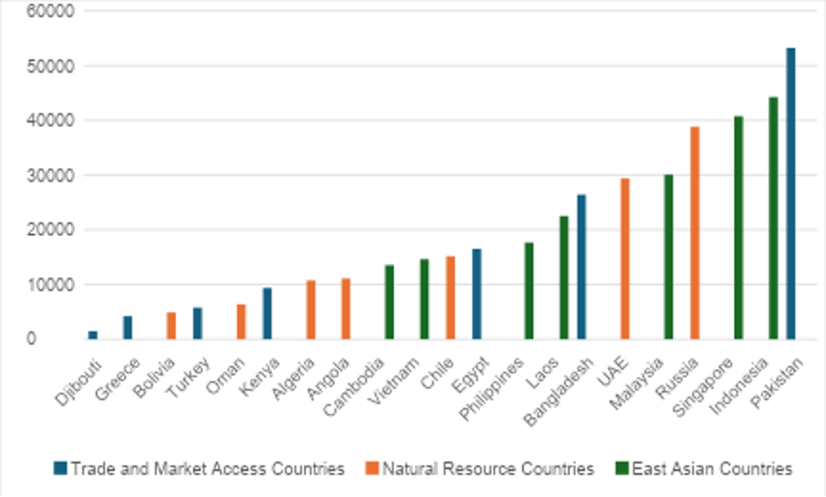
Fig. 2 is the next graphical representation of this data. It shows the proportion of total BRI-related spending allocated to countries in each of the three categories: East Asian countries, resource-rich countries, and countries providing access to new markets.

Fig. 2
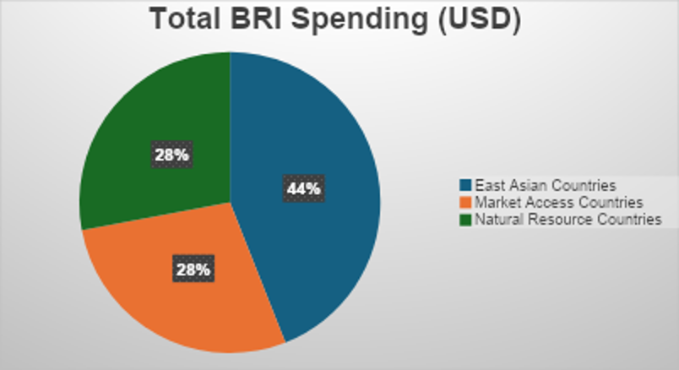
Pie chart representing proportion of total BRI-related spending in each category
Using this data, we can provide some preliminary answers to the research question. These findings show that the hypothesis that best explains the variance in Chinese BRI-related spending is the desire for East Asian dominance. While all the hypotheses have merit and do influence Chinese spending, the data indicates that Chinese spending is higher in East Asian Countries. As shown in the pie chart of the total spending in all 21 countries, East Asian countries account for 44% of that spending (see Fig. 2). The rest of the 56% was split evenly between the countries that provide natural resources and those that allow access to new markets. Furthermore, the bar graph shows that, from this sample, two of the top three recipient countries, Singapore and Indonesia, are East Asian countries (see Fig. 1). On the other hand, the bottom three least invested in countries in the sample do not include any East Asian countries (see Fig. 1). In fact, the East Asian country with the lowest-ranked investment, Cambodia, still ranks ninth lowest overall (see Fig. 1). Therefore, this research finds that China spends more on BRI investment and construction projects in East Asian countries. These findings most closely match H2 of the testable hypotheses. Thus, these findings cement the theory that East Asian dominance is a key objective for China.

Conclusion
While the BRI was initially launched to revitalize the Chinese economy by offloading industrial overcapacity, it has also facilitated greater economic integration between China and all the countries involved. Moreover, it has allowed China easier access to natural resources and new markets to sell its goods. This research shows that Chinese BRI-related spending is highest in East Asian countries, suggesting that the desire for East Asian dominance informs the variance of BRI projects in different countries. These findings offer a preliminary answer to the question, “Why does Chinese diplomacy surrounding the Belt and Road Initiative vary from country to country?” While insightful, the results are based on a relatively small sample of 21 countries. As such, they should be considered as a starting point for further investigation. More robust and comprehensive studies are needed to provide validity and extend these conclusions.
Previous extensive research has refuted the idea that China is deliberately pursuing a strategy of “debt-trap diplomacy”. However, this study reveals that the BRI does have geostrategic motivations. The focus on East Asian countries found in this study shows that China’s geopolitical goals for the BRI extend beyond the cooperative objectives outlined in the Action Plan. These findings also reinforce how much China stands to gain from the BRI. While it is constructing infrastructure projects that a lot of the recipient countries need, it is also securing reliable, long-term access to natural resources, access to new markets, as well as building a foundation for its aims of East Asian dominance. These findings are also consequential considering the rising tensions over Taiwan as East Asian dominance will be a geopolitical advantage in achieving their goals regarding Taiwan’s status.
Research on the BRI is important because of the implications the initiative has for the international world order. The BRI represents more than a collection of infrastructure projects; it marks an expansion of Chinese influence to the world. It signals that the Chinese Communist Party (CCP) is increasingly more willing to adopt an active and critical role in shaping the world order. Through this, Beijing is changing the international geopolitical landscape from one historically centered around the US and its Western allies, to one in which China plays a far more formidable role. With China’s long-term goal of East Asian dominance in mind, only time will tell how momentous the BRI is for the future of Asia and the future of the world.

BIBLIOGRAPHY
Acker, Kevin, Deborah Brautigam and Yufan Huang. “Debt Relief with Chinese Characteristics” Working Paper No. 2020/39. China Africa Research Initiative, School of Advanced International Studies, Johns Hopkins University, Washington, DC. Retrieved from http://www.sais-cari.org/publications.
Ahmad, Tariq, Author, Laney Zhang, Nicolas Boring, George Sadek, Hanibal Goitom, Sayuri Umeda, Kelly Buchanan, et al. Belt and Road Initiative: China, Cambodia, Caribbean Countries, Djibouti, Egypt, Greece, Kenya, Luxembourg, Malaysia, Pakistan, Philippines, Portugal, Russian Federation and Central Asian Countries, South America, Sweden, Switzerland, United Kingdom. Washington, D.C.: The Law Library of Congress, Global Legal Research Directorate, August, 2021. Pdf. https://www.loc.gov/item/2021687414/.
Anh, Dang Viet, and Nguyen Le Quynh Chi. “Cdr – the Belt and Road Initiative: Vietnam: ICLG.” Arbitration, Litigation, Dispute Resolution | CDR Magazine. Global Legal Group. Accessed December 13, 2022. https://iclg.com/cdr-essential-intelligence/1100-cdr-the-belt-and-road-initiative-2021/vietnam#:~:text=The%20remarkable%20BRI%20projects%20in,capital%20of%20USD%202.16%20billion.
Berger, H. Blake and Russel, Daniel R. “Weaponizing the Belt and Road Initiative” Asia Society, September 2020. https://asiasociety.org/policy-institute/weaponizing-belt-and-road-initiative.
Carrai, Maria Adele. "China's Malleable Sovereignty along the Belt and Road Initiative: The Case of the 99-Year Chinese Lease of Hambantota Port," New York University Journal of International Law and Politics 51,no. 4 (2019): 1061-1100.
Chheang, Vannarith. “2021/99 ‘BRI Projects in Cambodia and Laos Roll on despite Covid-19’ .” ISEAS, July 27, 2021. https://www.iseas.edu.sg/articles-commentaries/iseas-perspective/2021-99-bri-projects-in-cambodia-and-laos-roll-on-despite-covid-19-by-vannarith-chheang/#:~:text=MAIN%20BRI%20PROJECTS%20IN%20LAOS&text=The%20Sino%2DLao%20and%20Sino,construct%2C%20connecting%20Kunming%20with%20Singapore
Devonshire-Ellis, Chris. “Algeria to Coordinate National Development Plans with China's Belt and Road Initiative.” Silk Road Briefing, July 27, 2021. https://www.silkroadbriefing.com/news/2021/07/27/algeria-to-coordinate-national-development-plans-with-chinas-belt-and-road-initiative/
Du, Michael M. "China's "One Belt, One Road" Initiative: Context, Focus, Institutions, and Implications." The Chinese Journal of Global Governance 2, no. 1 (2016): 30-43
Embassy of China. “Latest Progress on the CPEC.” Latest progress on the CPEC. Accessed December 13, 2022. http://pk.china-embassy.gov.cn/eng/zbgx/201812/t20181230_1134724.htm.
Hanks, Joshua. “Bolivia, Lithium and China's BRI.” Workers World, January 1, 2020. https://www.workers.org/2019/11/44493/#:~:text=It%27s%20intended%20as%20an%20outlet,grip%20of%20Washington%20and%20Brussels. '.
Han, Yang. “UAE Project Progresses under BRI.” China Daily, January 2022. https://www.chinadailyhk.com/article/256991.
He, Wenping. “Opinion: Bri Injects New Energy into China-Angola Cooperation.” CGTN, 2018. https://news.cgtn.com/news/3d3d514f77557a4e7a457a6333566d54/share_p.html.
Jones, Lee, and Shahar Hameiri. “Debunking the Myth of 'Debt-Trap Diplomacy'.” Chatham House – International Affairs Think Tank, December 14, 2020. https://www.chathamhouse.org/2020/08/debunking-myth-debt-trap-diplomacy.
McBeth, John. “China's Belt and Road Staggers and Stalls in Indonesia.” Asia Times. Asia Times, September 17, 2022. https://asiatimes.com/2022/07/chinas-belt-and-road-staggers-and-stalls-in-indonesia/.
Mearsheimer, John. “China's Unpeaceful Rise,” Current History 105, no. 690 (2006): 160-162.
OECD. "The Belt and Road Initiative in the global trade, investment and finance landscape", OECD Business and Finance Outlook 2018, OECD Publishing, Paris, September 2018. https://doi.org/10.1787/bus_fin_out-2018-6-en.
Salamatin, Mikkaela. "China's Belt and Road Initiative is Reshaping Human Rights Norms." Vanderbilt Journal of Transnational Law 53, no. 4 (2020): 1427-1476.
Scissors, Derek. “China Global Investment Tracker | American Enterprise Institute - AEI.” Accessed December 6, 2022. https://www.aei.org/china-global-investment-tracker/.
Solutions, EIU Digital. UAE signs deals with China under Belt and Road Initiative, 2019. https://country.eiu.com/article.aspx?articleid=1857968369.
State Council of the People's Republic of China. “Action Plan on the Belt and Road Initiative.” Initiative offers Road Map for Peace, prosperity. Accessed December 13, 2022. http://english.www.gov.cn/archive/publications/2015/03/30/content_281475080249035.htm.
Stewart, Megan A., Gönül Tol, and Yörük Işık. “China's Belt and Road Initiative (BRI) and Turkey's Middle Corridor: ‘Win-Win Cooperation’?” Middle East Institute, December 7, 2022. https://www.mei.edu/publications/chinas-belt-and-road-initiative-bri-and-turkeys-middle-corridor-win-win-cooperation.
WANG, Christoph NEDOPIL. “Countries of the Belt and Road Initiative (BRI).” Green Finance & Development Center, July 2022. https://greenfdc.org/countries-of-the-belt-and-road-initiative-bri/.
Yee, Gerald. “Eight Years on - an Overview of the Belt and Road Initiative.” The Singapore Law Gazette, November 23, 2021. https://lawgazette.com.sg/news/updates/eight-years-on-belt-road-legal-insurance/.
Ye, Min. Cambridge Core All Books, and Cambridge Core EBA eBooks Complete Collection. The Belt Road and Beyond. New York, NY; Cambridge, United Kingdom: Cambridge University Press, 2020.
郑成琼. “What Are Six Economic Corridors under Belt and Road Initiative?” The State Council Information Office of the People's Republic of China. Accessed December 8, 2022. http://english.scio.gov.cn/beltandroad/2020-08/04/content_76345602.htm.
孙晓宇. “BRI Provides Benefits for Bangladesh.” Chinadaily.com.cn. Accessed December 13, 2022. https://global.chinadaily.com.cn/a/202110/11/WS6163e762a310cdd39bc6e219.html

APPENDIX
APPENDIX A: Raw Data on East Asian Countries
BRI-related Investment and Construction Spending in Cambodia:
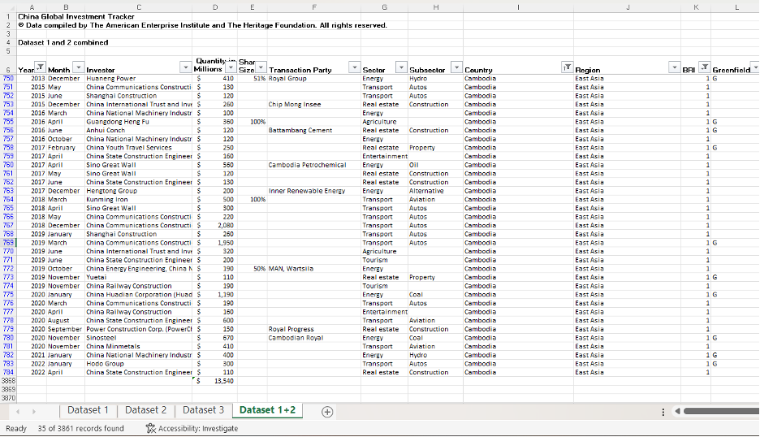
BRI-related Investment and Construction Spending in Singapore:
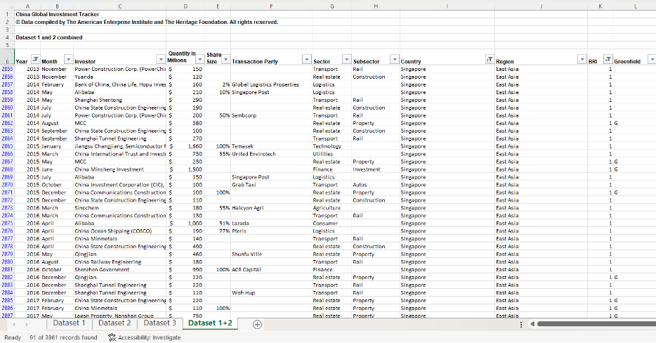
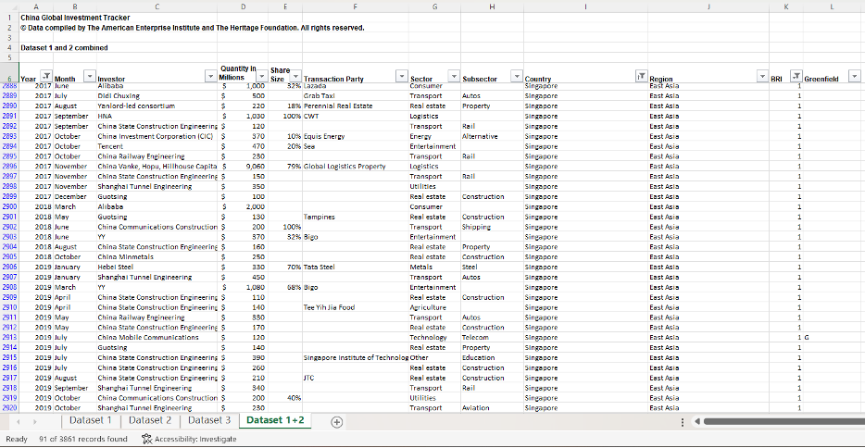
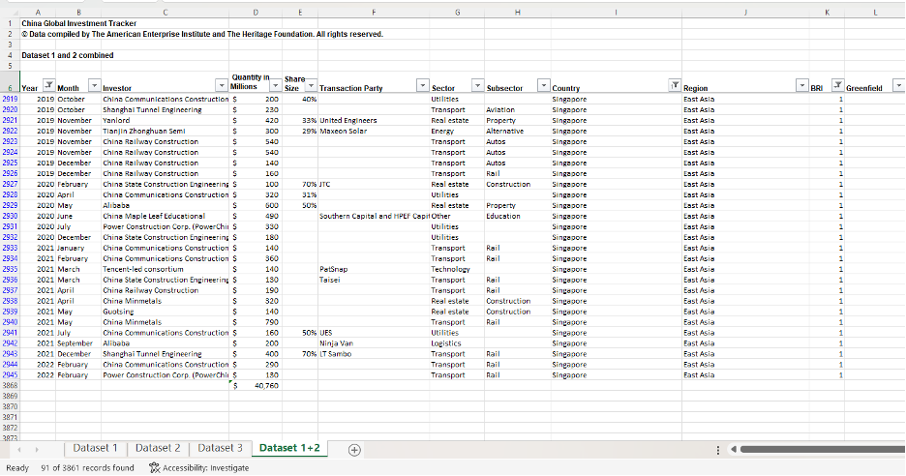

BRI-related Investment and Construction Spending in Philippines:
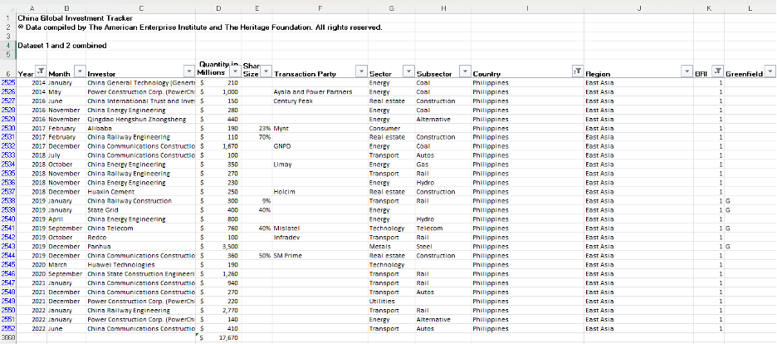
BRI-related Investment and Construction Spending in Laos:
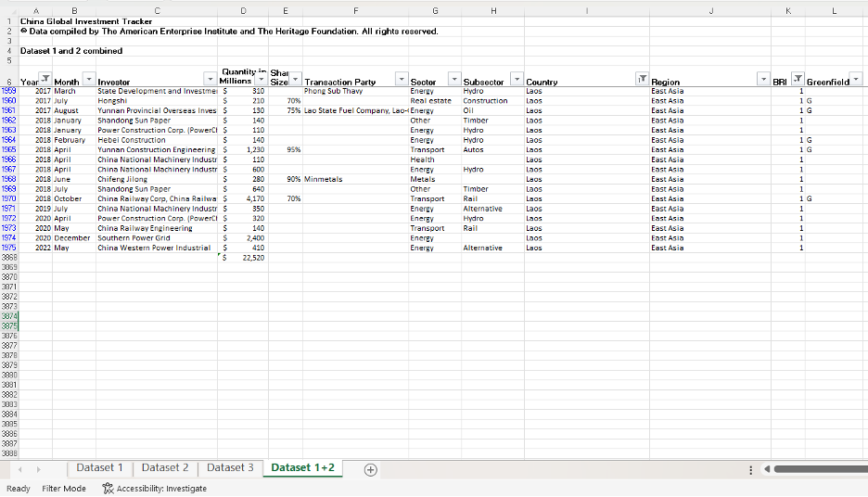

BRI-related Investment and Construction Spending in Indonesia:
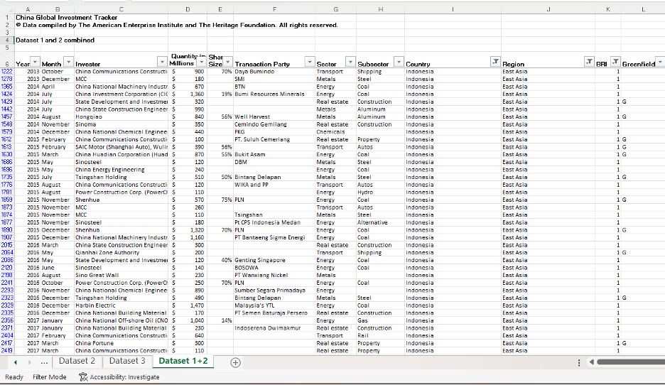
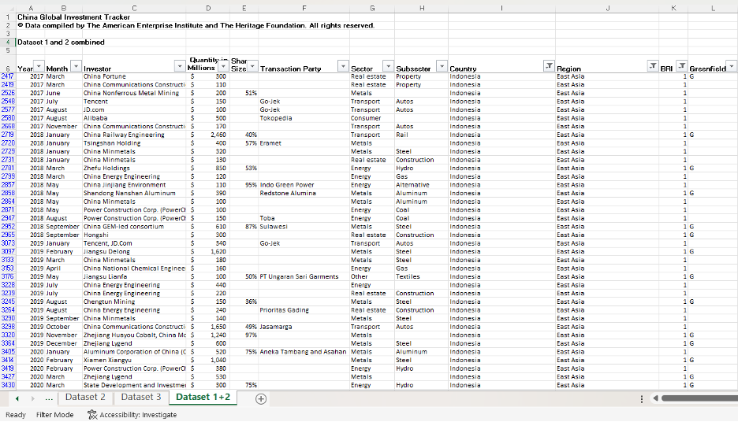
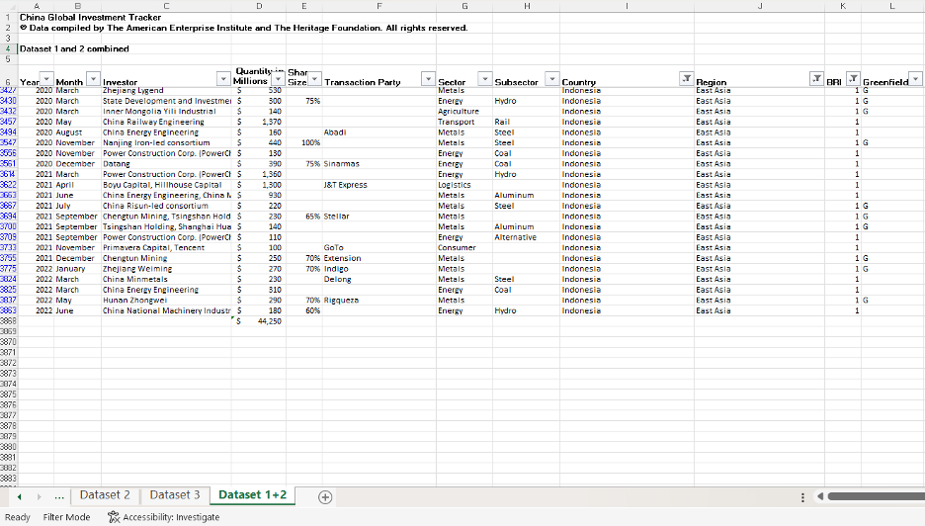
BRI-related Investment and Construction Spending in Vietnam:
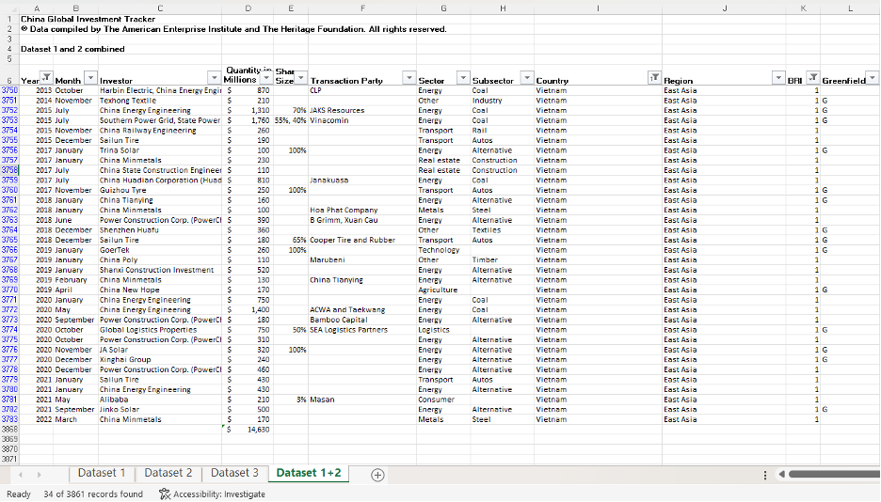

BRI-related Investment and Construction Spending in Malaysia:
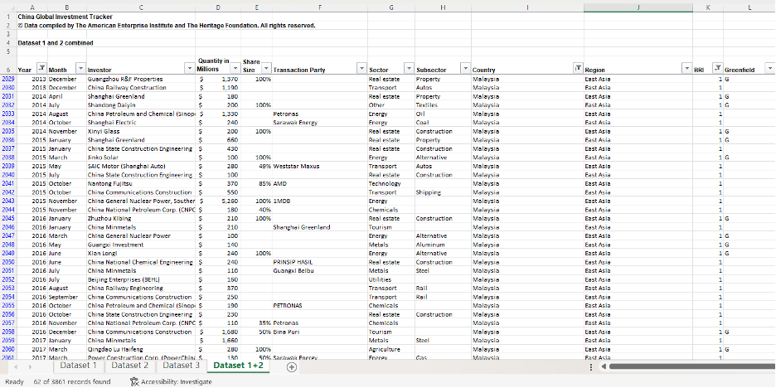
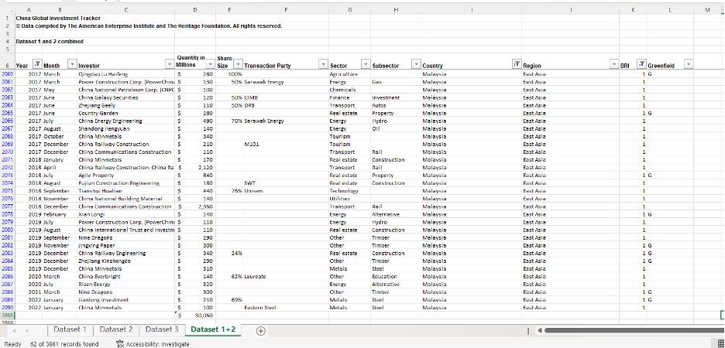

APPENDIX B: Raw Data on countries that allow access to new markets
BRI-related Investment and Construction Spending in Greece:
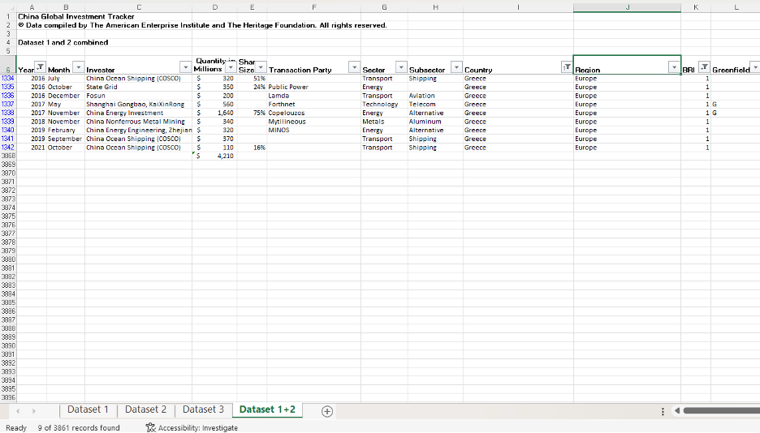
BRI-related Investment and Construction Spending in Kenya:
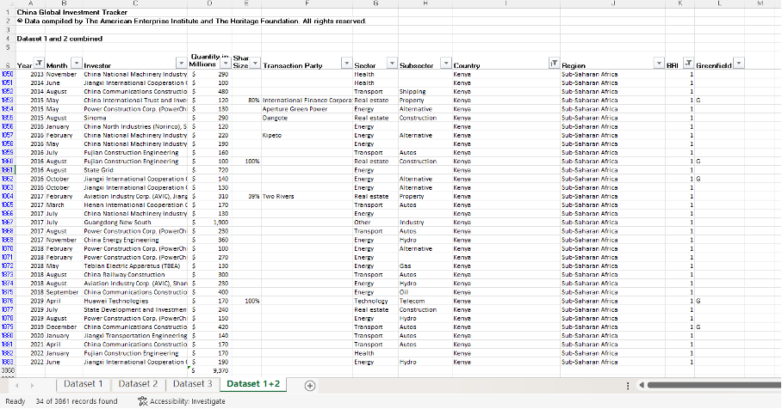

BRI-related Investment and Construction Spending in Pakistan:
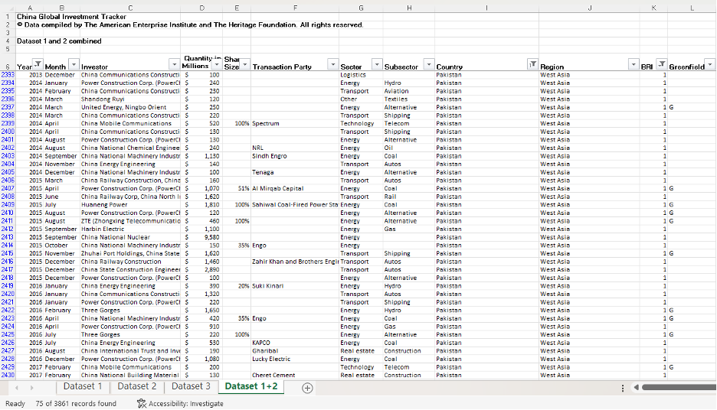
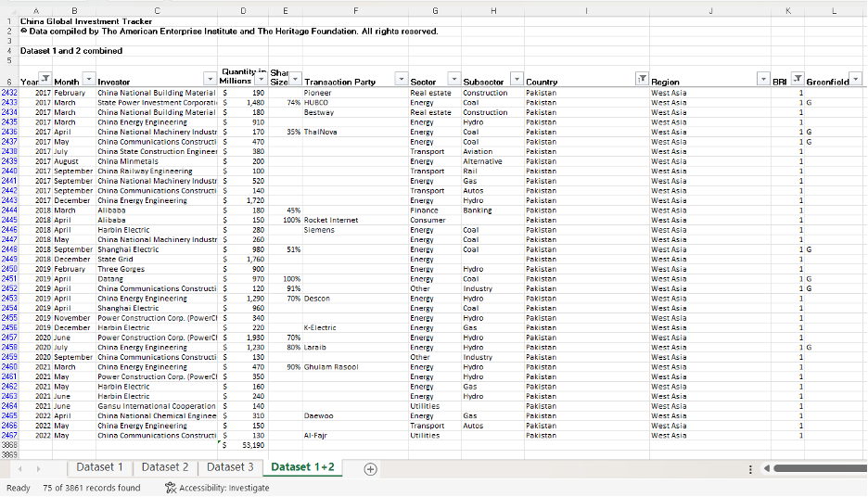

BRI-related Investment and Construction Spending in Djibouti:
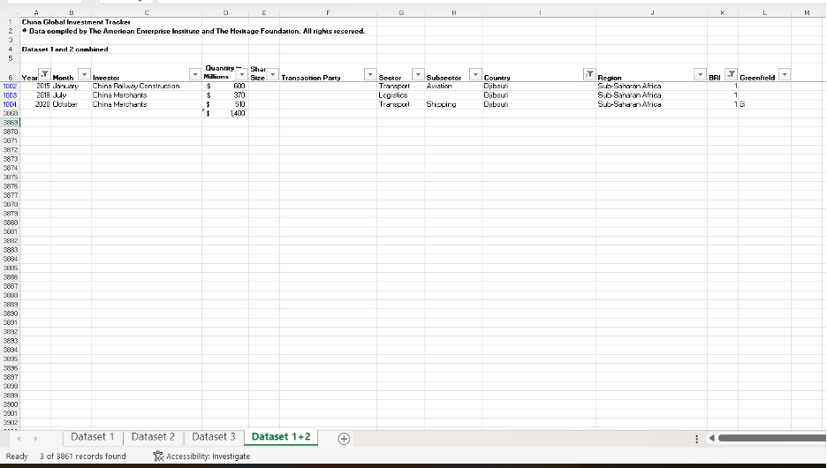
BRI-related Investment and Construction Spending in Egypt:
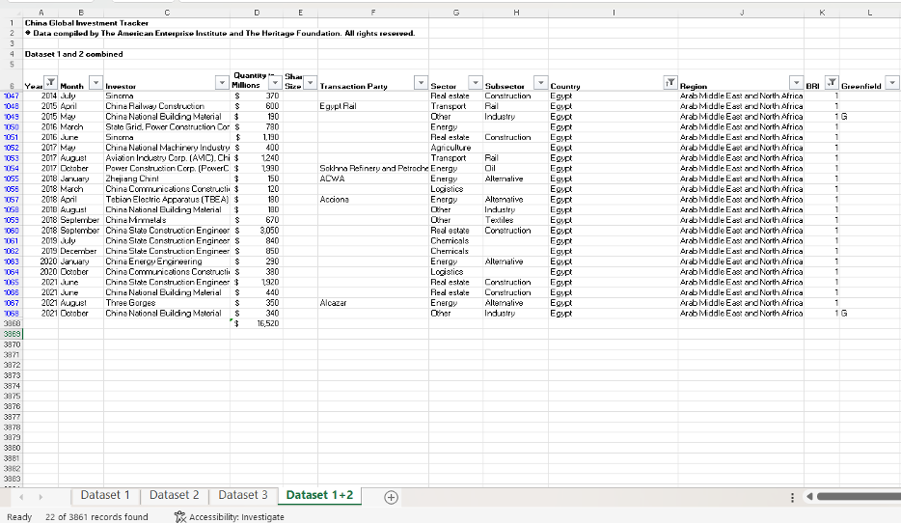

BRI-related Investment and Construction Spending in Turkey:
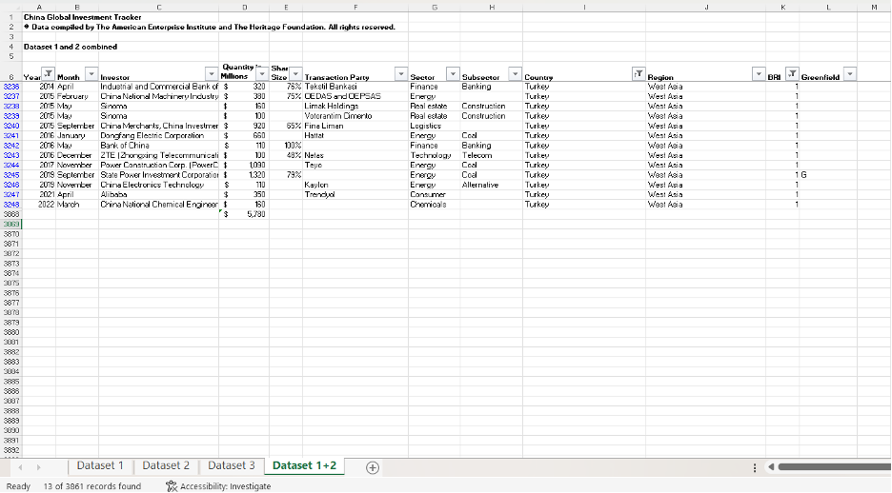
BRI-related Investment and Construction Spending in Bangladesh:
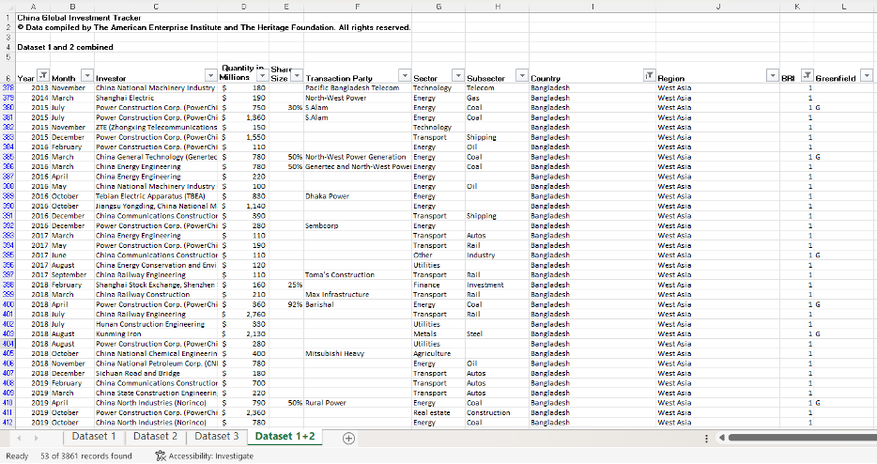
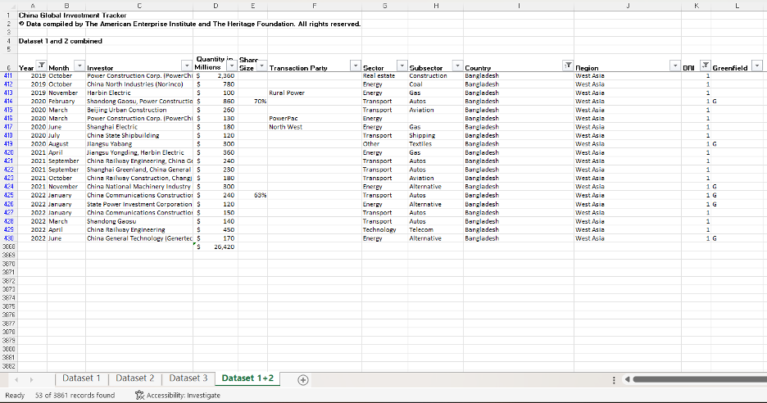

APPENDIX C: Raw Data on countries with abundant natural resources
BRI-related Investment and Construction Spending in Algeria
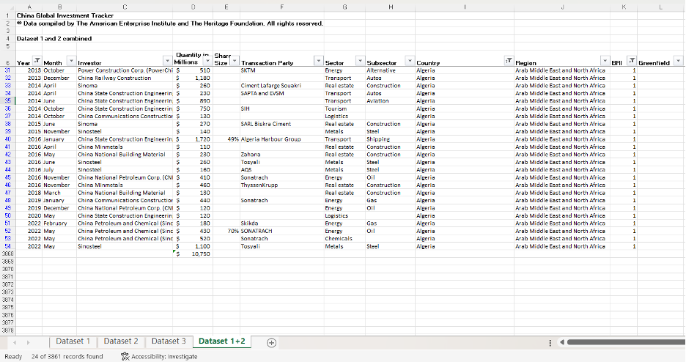

BRI-related Investment and Construction Spending in Russia:
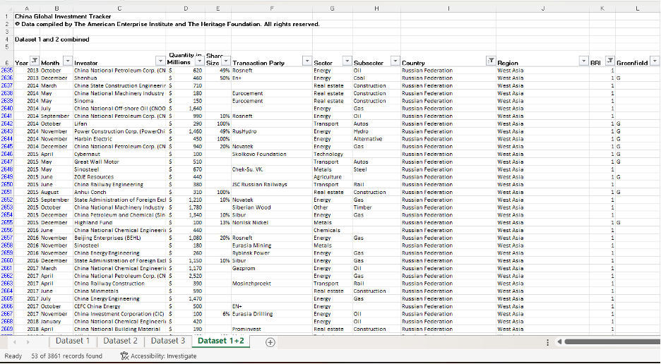
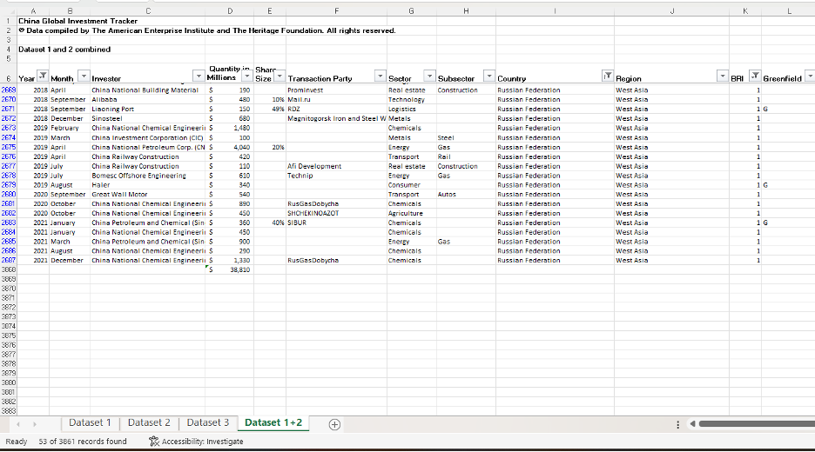

BRI-related Investment and Construction Spending in Angola:
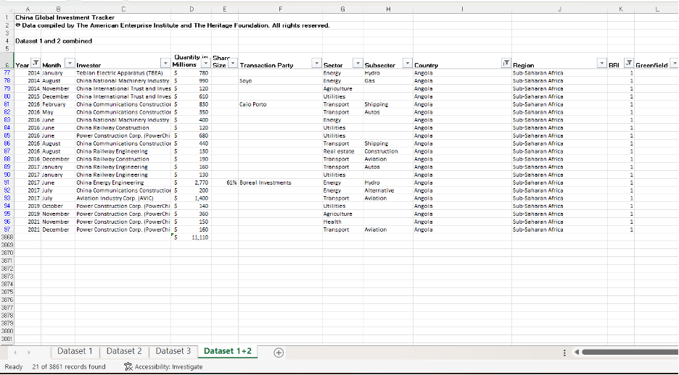
BRI-related Investment and Construction Spending in Oman:
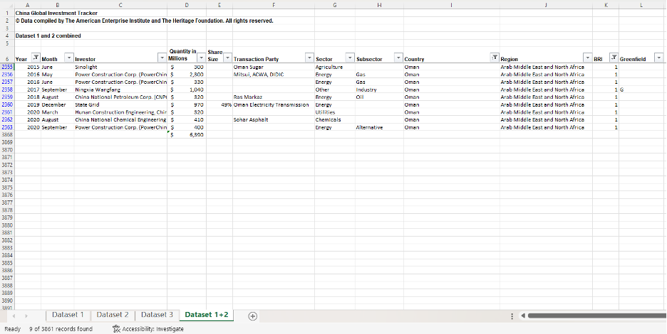

BRI-related Investment and Construction Spending in UAE:
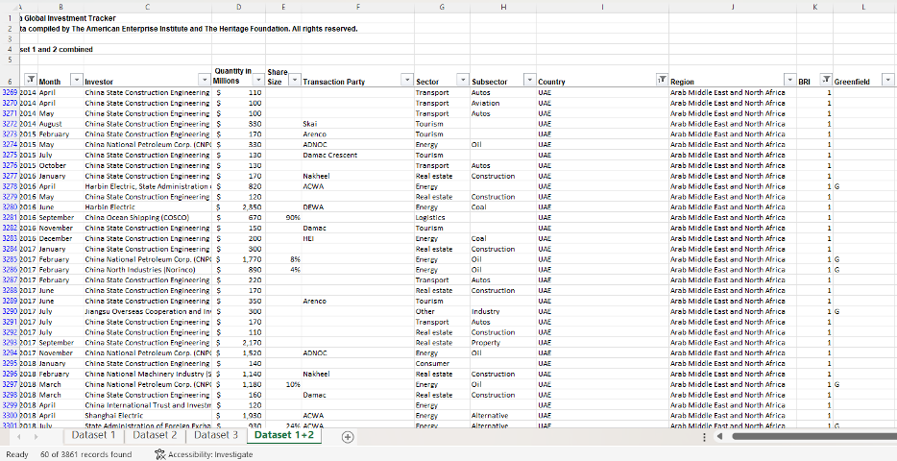
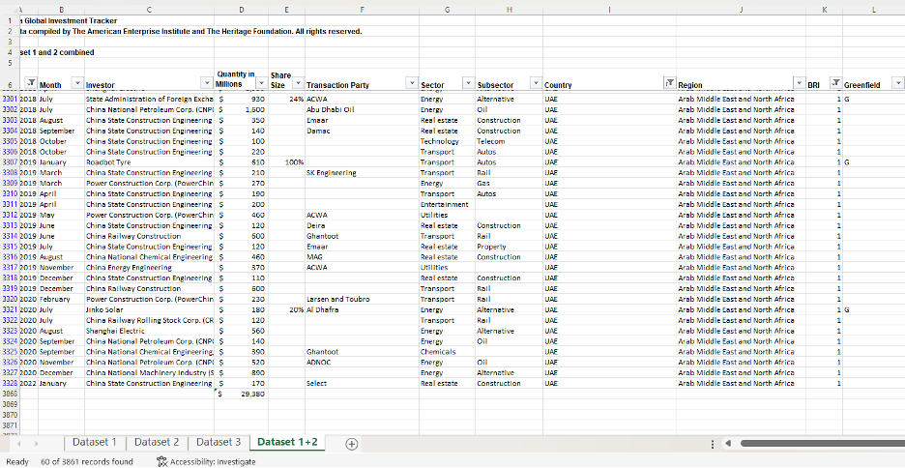

BRI-related Investment and Construction Spending in Chile:
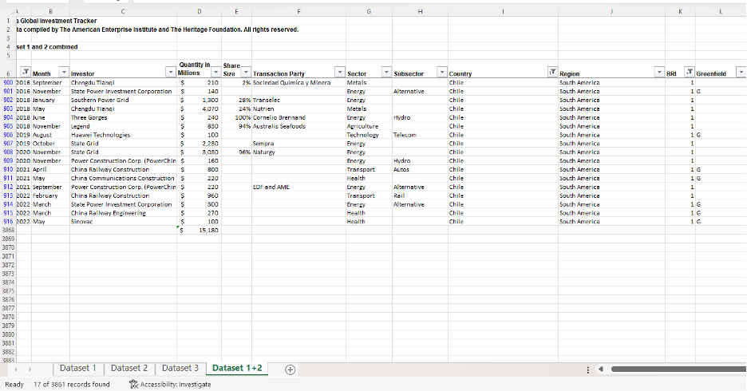
BRI-related Investment and Construction Spending in Bolivia:
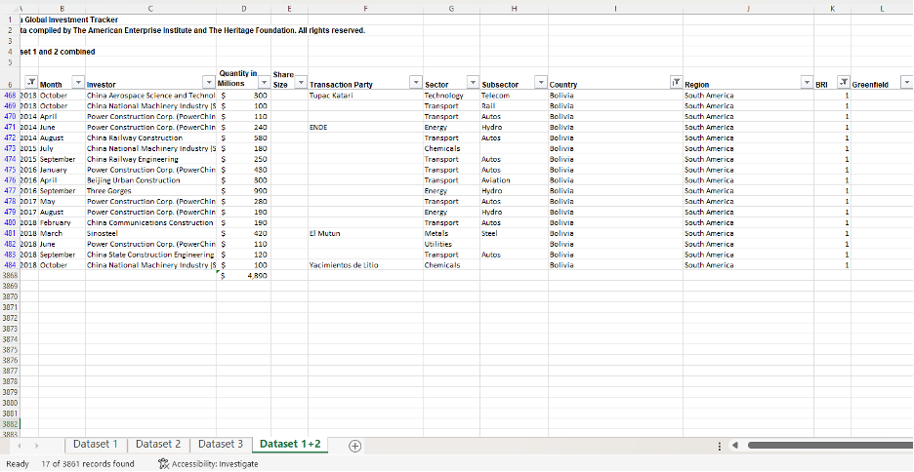

Du, Michael M. "China's "One Belt, One Road" Initiative: Context, Focus, Institutions, and Implications." The Chinese Journal of Global Governance 2, no. 1 (2016): 31.
Ibid.
郑成琼. “What Are Six Economic Corridors under Belt and Road Initiative?” The State Council Information Office of the People's Republic of China. Accessed December 8, 2022. http://english.scio.gov.cn/beltandroad/2020-08/04/content_76345602.htm.
Aweis Osman, China’s Maritime Silk Road and the Future of African Arbitration, in The Belt and Road Initiative: Law, Economics, and Politics 734, 734-735 (Julien Chaisse & Jędrzej Górski eds., 2018).
WANG, Christoph NEDOPIL. “Countries of the Belt and Road Initiative (BRI).” Green Finance & Development Center, July 2022. https://greenfdc.org/countries-of-the-belt-and-road-initiative-bri/.
Ye, Min, Cambridge Core All Books, and Cambridge Core EBA eBooks Complete Collection. The Belt Road and Beyond. New York, NY; Cambridge, United Kingdom;: Cambridge University Press, 2020, 7.
OECD, "The Belt and Road Initiative in the global trade, investment and finance landscape", OECD Business and Finance Outlook 2018, OECD Publishing, Paris, September 2018. https://doi.org/10.1787/bus_fin_out-2018-6-en, 4.
State Council of the People's Republic of China. “Action Plan on the Belt and Road Initiative.” Initiative offers Road Map for Peace, prosperity. Accessed December 13, 2022. http://english.www.gov.cn/archive/publications/2015/03/30/content_281475080249035.htm.
Du, Michael M. "China's "One Belt, One Road" Initiative: Context, Focus, Institutions, and Implications." The Chinese Journal of Global Governance 2, no. 1 (2016): 32.
Salamatin, Mikkaela. "China's Belt and Road Initiative is Reshaping Human Rights Norms." Vanderbilt Journal of Transnational Law 53, no. 4 (2020): 1427-1476.1435.
Ibid.
OECD, "The Belt and Road Initiative in the global trade, investment and finance landscape", OECD Business and Finance Outlook 2018, OECD Publishing, Paris, September 2018. https://doi.org/10.1787/bus_fin_out-2018-6-en, 5. WEPON.
Fahmida Alam and Samin Farhan Asef, “The Implications of BRI in Djibouti: A Critical Geopolitical Analysis,” in Research Association for Interdisciplinary Studies Conference Proceedings, August 17-18, 2020, 279, https://doi.org/10.5281/zenodo.400614.
Carrai, Maria Adele "China's Malleable Sovereignty along the Belt and Road Initiative: The Case of the 99-Year Chinese Lease of Hambantota Port," New York University Journal of International Law and Politics 51, no. 4 (2019): 1098.
Acker, Kevin, Deborah Brautigam and Yufan Huang. “Debt Relief with Chinese Characterists” Working Paper No. 2020/39. China Africa Research Initiative, School of Advanced International Studies, Johns Hopkins University, Washington, DC. Retrieved from http://www.sais-cari.org/publications, 3.
Ibid.
WANG, Christoph NEDOPIL. “Countries of the Belt and Road Initiative (BRI).” Green Finance & Development Center, July 2022. https://greenfdc.org/countries-of-the-belt-and-road-initiative-bri/.
Ibid.
Berger, H. Blake and Russel, Daniel R. “Weaponizing the Belt and Road Initiative” Asia Society, September 2020. https://asiasociety.org/policy-institute/weaponizing-belt-and-road-initiative, 6.
Ibid, 23.
Ibid, 9.
Mearsheimer, John. “China's Unpeaceful Rise,” Current History 105, no. 690 (2006): 160-162..
Berger, H. Blake and Russel, Daniel R. “Weaponizing the Belt and Road Initiative” Asia Society, September 2020. https://asiasociety.org/policy-institute/weaponizing-belt-and-road-initiative, 3.
Scissors, Derek. “China Global Investment Tracker | American Enterprise Institute - AEI.” Accessed December 6, 2022. https://www.aei.org/china-global-investment-tracker/.
Berger, H. Blake and Russel, Daniel R. “Weaponizing the Belt and Road Initiative” Asia Society, September 2020. https://asiasociety.org/policy-institute/weaponizing-belt-and-road-initiative, 7.
Ahmad, Tariq, Author, Laney Zhang, Nicolas Boring, George Sadek, Hanibal Goitom, Sayuri Umeda, Kelly Buchanan, et al. Belt and Road Initiative: China, Cambodia, Caribbean Countries, Djibouti, Egypt, Greece, Kenya, Luxembourg, Malaysia, Pakistan, Philippines, Portugal, Russian Federation and Central Asian Countries, South America, Sweden, Switzerland, United Kingdom. Washington, D.C.: The Law Library of Congress, Global Legal Research Directorate, August, 2021. Pdf. https://www.loc.gov/item/2021687414/, 58.
Devonshire-Ellis, Chris. “Algeria to Coordinate National Development Plans with China's Belt and Road Initiative,” Silk Road Briefing, July 27, 2021, https://www.silkroadbriefing.com/news/2021/07/27/algeria-to-coordinate-national-development-plans-with-chinas-belt-and-road-initiative/.
Ahmad, Tariq, Author, Laney Zhang, Nicolas Boring, George Sadek, Hanibal Goitom, Sayuri Umeda, Kelly Buchanan, et al. Belt and Road Initiative: China, Cambodia, Caribbean Countries, Djibouti, Egypt, Greece, Kenya, Luxembourg, Malaysia, Pakistan, Philippines, Portugal, Russian Federation and Central Asian Countries, South America, Sweden, Switzerland, United Kingdom. Washington, D.C.: The Law Library of Congress, Global Legal Research Directorate, August, 2021. Pdf. https://www.loc.gov/item/2021687414/, 146.
Ibid.
He , Wenping. “Opinion: Bri Injects New Energy into China-Angola Cooperation.” CGTN, 2018. https://news.cgtn.com/news/3d3d514f77557a4e7a457a6333566d54/share_p.html.
Ahmad, Tariq, Author, Laney Zhang, Nicolas Boring, George Sadek, Hanibal Goitom, Sayuri Umeda, Kelly Buchanan, et al. Belt and Road Initiative: China, Cambodia, Caribbean Countries, Djibouti, Egypt, Greece, Kenya, Luxembourg, Malaysia, Pakistan, Philippines, Portugal, Russian Federation and Central Asian Countries, South America, Sweden, Switzerland, United Kingdom. Washington, D.C.: The Law Library of Congress, Global Legal Research Directorate, August, 2021. Pdf. https://www.loc.gov/item/2021687414/, 36.
Ibid.
Han, Yang. “UAE Project Progresses under BRI.” China Daily, January 2022. https://www.chinadailyhk.com/article/256991.
Solutions, EIU Digital. UAE signs deals with China under Belt and Road Initiative, 2019. https://country.eiu.com/article.aspx?articleid=1857968369.
Ahmad, Tariq, Author, Laney Zhang, Nicolas Boring, George Sadek, Hanibal Goitom, Sayuri Umeda, Kelly Buchanan, et al. Belt and Road Initiative: China, Cambodia, Caribbean Countries, Djibouti, Egypt, Greece, Kenya, Luxembourg, Malaysia, Pakistan, Philippines, Portugal, Russian Federation and Central Asian Countries, South America, Sweden, Switzerland, United Kingdom. Washington, D.C.: The Law Library of Congress, Global Legal Research Directorate, August, 2021. Pdf. https://www.loc.gov/item/2021687414/, 157.
Devonshire-Ellis, Chris. “Algeria to Coordinate National Development Plans with China's Belt and Road Initiative,” Silk Road Briefing, July 27, 2021, https://www.silkroadbriefing.com/news/2021/07/27/algeria-to-coordinate-national-development-plans-with-chinas-belt-and-road-initiative/.
Hanks, Joshua. “Bolivia, Lithium and China's BRI.” Workers World, January 1, 2020. https://www.workers.org/2019/11/44493/#:~:text=It%27s%20intended%20as%20an%20outlet,grip%20of%20Washington%20and%20Brussels.
Ahmad, Tariq, Author, Laney Zhang, Nicolas Boring, George Sadek, Hanibal Goitom, Sayuri Umeda, Kelly Buchanan, et al. Belt and Road Initiative: China, Cambodia, Caribbean Countries, Djibouti, Egypt, Greece, Kenya, Luxembourg, Malaysia, Pakistan, Philippines, Portugal, Russian Federation and Central Asian Countries, South America, Sweden, Switzerland, United Kingdom. Washington, D.C.: The Law Library of Congress, Global Legal Research Directorate, August, 2021. Pdf. https://www.loc.gov/item/2021687414/, 67.
Ahmad, Tariq, Author, Laney Zhang, Nicolas Boring, George Sadek, Hanibal Goitom, Sayuri Umeda, Kelly Buchanan, et al. Belt and Road Initiative: China, Cambodia, Caribbean Countries, Djibouti, Egypt, Greece, Kenya, Luxembourg, Malaysia, Pakistan, Philippines, Portugal, Russian Federation and Central Asian Countries, South America, Sweden, Switzerland, United Kingdom. Washington, D.C.: The Law Library of Congress, Global Legal Research Directorate, August, 2021. Pdf. https://www.loc.gov/item/2021687414/, 67.
Yee, Gerald. “Eight Years on - an Overview of the Belt and Road Initiative.” The Singapore Law Gazette, November 23, 2021. https://lawgazette.com.sg/news/updates/eight-years-on-belt-road-legal-insurance/.
Ahmad, Tariq, Author, Laney Zhang, Nicolas Boring, George Sadek, Hanibal Goitom, Sayuri Umeda, Kelly Buchanan, et al. Belt and Road Initiative: China, Cambodia, Caribbean Countries, Djibouti, Egypt, Greece, Kenya, Luxembourg, Malaysia, Pakistan, Philippines, Portugal, Russian Federation and Central Asian Countries, South America, Sweden, Switzerland, United Kingdom. Washington, D.C.: The Law Library of Congress, Global Legal Research Directorate, August, 2021. Pdf. https://www.loc.gov/item/2021687414/, 124.
Chheang, Vannarith. “2021/99 ‘BRI Projects in Cambodia and Laos Roll on despite Covid-19’ .” ISEAS, July 27, 2021. https://www.iseas.edu.sg/articles-commentaries/iseas-perspective/2021-99-bri-projects-in-cambodia-and-laos-roll-on-despite-covid-19-by-vannarith-chheang/#:~:text=MAIN%20BRI%20PROJECTS%20IN%20LAOS&text=The%20Sino%2DLao%20and%20Sino,construct%2C%20connecting%20Kunming%20with%20Singapore.
McBeth, John. “China's Belt and Road Staggers and Stalls in Indonesia.” Asia Times. Asia Times, September 17, 2022. https://asiatimes.com/2022/07/chinas-belt-and-road-staggers-and-stalls-in-indonesia/.
Ahmad, Tariq, Author, Laney Zhang, Nicolas Boring, George Sadek, Hanibal Goitom, Sayuri Umeda, Kelly Buchanan, et al. Belt and Road Initiative: China, Cambodia, Caribbean Countries, Djibouti, Egypt, Greece, Kenya, Luxembourg, Malaysia, Pakistan, Philippines, Portugal, Russian Federation and Central Asian Countries, South America, Sweden, Switzerland, United Kingdom. Washington, D.C.: The Law Library of Congress, Global Legal Research Directorate, August, 2021. Pdf. https://www.loc.gov/item/2021687414/, 87.
Anh, Dang Viet, and Nguyen Le Quynh Chi. “Cdr – the Belt and Road Initiative: Vietnam: ICLG.” Arbitration,Litigation,Dispute Resolution | CDR Magazine. Global Legal Group. Accessed December 13, 2022. https://iclg.com/cdr-essential-intelligence/1100-cdr-the-belt-and-road-initiative-2021/vietnam#:~:text=The%20remarkable%20BRI%20projects%20in,capital%20of%20USD%202.16%20billion.
Ibid, 160.
Ibid.
Ahmad, Tariq, Author, Laney Zhang, Nicolas Boring, George Sadek, Hanibal Goitom, Sayuri Umeda, Kelly Buchanan, et al. Belt and Road Initiative: China, Cambodia, Caribbean Countries, Djibouti, Egypt, Greece, Kenya, Luxembourg, Malaysia, Pakistan, Philippines, Portugal, Russian Federation and Central Asian Countries, South America, Sweden, Switzerland, United Kingdom. Washington, D.C.: The Law Library of Congress, Global Legal Research Directorate, August, 2021. Pdf. https://www.loc.gov/item/2021687414/, 37.
Ibid.
Embassy of China. “Latest Progress on the CPEC.” Latest progress on the CPEC. Accessed December 13, 2022. http://pk.china-embassy.gov.cn/eng/zbgx/201812/t20181230_1134724.htm.
Ahmad, Tariq, Author, Laney Zhang, Nicolas Boring, George Sadek, Hanibal Goitom, Sayuri Umeda, Kelly Buchanan, et al. Belt and Road Initiative: China, Cambodia, Caribbean Countries, Djibouti, Egypt, Greece, Kenya, Luxembourg, Malaysia, Pakistan, Philippines, Portugal, Russian Federation and Central Asian Countries, South America, Sweden, Switzerland, United Kingdom. Washington, D.C.: The Law Library of Congress, Global Legal Research Directorate, August, 2021. Pdf. https://www.loc.gov/item/2021687414/,16.
Ibid, 15.
Ibid, 25.
Stewart, Megan A., Gönül Tol, and Yörük Işık. “China's Belt and Road Initiative (BRI) and Turkey's Middle Corridor: ‘Win-Win Cooperation’?” Middle East Institute, December 7, 2022. https://www.mei.edu/publications/chinas-belt-and-road-initiative-bri-and-turkeys-middle-corridor-win-win-cooperation.
孙晓宇. “BRI Provides Benefits for Bangladesh.” Chinadaily.com.cn. Accessed December 13, 2022. https://global.chinadaily.com.cn/a/202110/11/WS6163e762a310cdd39bc6e219.html.
Scissors, Derek. “China Global Investment Tracker | American Enterprise Institute - AEI.” Accessed December 6, 2022. https://www.aei.org/china-global-investment-tracker/.
Ibid.
Scissors, Derek. “China Global Investment Tracker | American Enterprise Institute - AEI.” Accessed December 6, 2022. https://www.aei.org/china-global-investment-tracker/.

